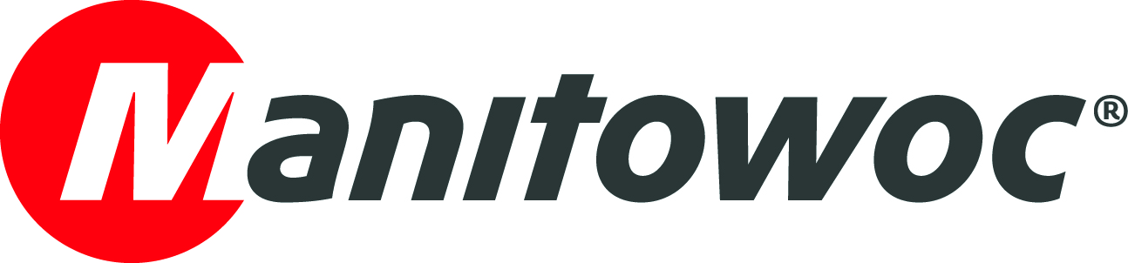
CAPTION RELEASE

March 14, 2018

Nigerian natural gas plant adds two Grove GMK5130-2 cranes

- The 130 t capacity all-terrain cranes will handle plant maintenance and construction work.
- The cranes combine reach and maneuverability, making them ideal for work in tight spaces.

Nigeria Liquid Natural Gas (NLNG) has purchased two Grove GMK5130-2 all-terrain cranes. The company runs one of the world’s largest gas liquefaction plants, from its facility on Bonny Island, Nigeria. The two 130 t capacity cranes will be used for plant maintenance and construction work.

The cranes broaden NLNG’s Grove fleet, joining an 80 t capacity GMK4080; a 100 t capacity GMK5100; a 160 t capacity GMK5160; and a 9 t capacity YB4410. The latest additions were supplied in late 2017 through Savvytech, the Grove dealer for Nigeria.

Seun Awoniyi, director of Savvytech, said NLNG has a long history of brand loyalty to Grove.

“NLNG has maintained a very strong relationship with Manitowoc for many years and has a lot of confidence in its cranes,” he said. “The most reliable cranes in its fleet are 20-year-old Grove machines; the return on investment has been fantastic for them. Now NLNG has updated its fleet with two GMK5130-2 cranes, which we’re confident will serve the company just as well.”

With its 60 m main boom and compact design, the five-axle GMK5130-2 offers a perfect combination of reach and maneuverability. This allows it to work with ease in the tight working spaces of the NLNG plant.

-END-

Andreas Cremer Oliver Halls
Manitowoc SE10
T +49 4421 294 4276 T +44 20 79 235 860
andreas.cremer@manitowoc.com oliver.halls@se10.com

ABOUT THE MANITOWOC COMPANY, INC.
Founded in 1902, The Manitowoc Company, Inc. is a leading global manufacturer of cranes and lifting solutions with manufacturing, distribution, and service facilities in 20 countries. Manitowoc is recognized as one of the premier innovators and providers of crawler cranes, tower cranes, and mobile cranes for the heavy construction industry, which are complemented by a slate of industry-leading aftermarket product support services. In 2017, Manitowoc’s net sales totaled $1.6 billion, with over half generated outside the United States.

THE MANITOWOC COMPANY, INC.
2400 S. 44th Street - PO Box 66 - Manitowoc, WI 54221, USA

T +1 920 684 4410
www.manitowoc.com

