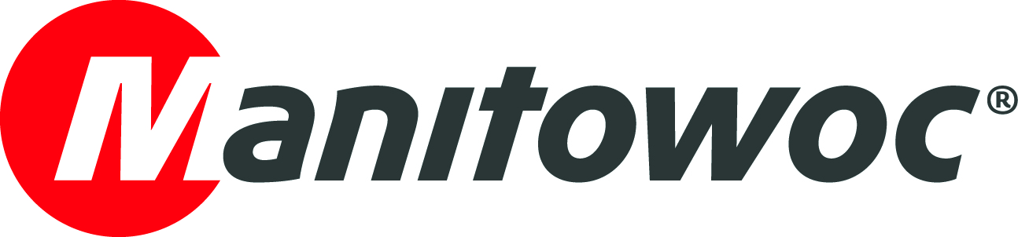
NEWS RELEASE
26 June 2018

Manitowoc boosts manufacturing productivity in Asia with new Indian tower crane factory

- Lean manufacturing initiatives of The Manitowoc Way plus new equipment help shorten lead times and enhance quality at new Pune facility.
- New factory is smaller than previous plant but with the same manufacturing capacity.
- The factory produces Potain MCT 85 and MC 125 cranes for customers in India, as well as surrounding markets such as Sri Lanka, Bangladesh and Nepal.

Manitowoc has opened a new Potain tower crane factory in the Indian city of Chakan, which lies outside Pune, with production beginning in first-quarter 2018. This facility replaces the company’s previous factory in Pune, which opened back in 2007. With a smaller land area as well as new equipment and lean processes, the new facility produces Potain MCT 85 and MC 125 cranes more efficiently and with even greater quality.

David Semple, Manitowoc’s senior vice president for the Middle East and India, said the development of the plant had been closely aligned to the principles of The Manitowoc Way.

“This new factory is another demonstration of how The Manitowoc Way business philosophy guides our operations,” he said. “We are focused on developing and executing lean strategies to improve efficiency, profitability, and value for our stakeholders. Our customers will benefit from the faster delivery times and enhanced quality of this new facility while our employees can feel proud to work at one of the most advanced tower crane factories in Asia. Potain has long been a market-leader in India and we want to ensure that continues, so opening this factory is an important step.”

With a production area of 9,760 m², the new factory’s manufacturing footprint has been reduced by one-third compared to its previous facility but has been designed for the same level of production output. Among the upgrades in equipment at the facility are a new paint shop and shot blasting machine cells, complemented by intensive worker training to ensure Manitowoc produces the finest tower crane products.

The facility layout delivers other productivity improvements. Most notably, the time to transport materials from the assembly area to the finished goods yard is reduced by 68%. There are other significant savings in material transport from the steel yard, supplier yard and fabrication area.

Time savings are not limited to onsite operations either. Although still in the Pune area, the new factory sits some 45 km from the old location, in the city’s industrial belt of Chakan. Being situated in Chakan offers better connectivity to national highways, speeding customer deliveries within India. In addition, the new facility is closer to Mumbai from where Potain cranes are shipped to export markets.

“The majority of cranes manufactured at this new factory will be shipped to customers in India,” said David Semple. “But we will also serve neighboring markets such as Sri Lanka, Bangladesh and Nepal. All of our customers will benefit from the faster deliveries and enhanced quality of Potain cranes in this region.”

The Potain MCT 85 and MC 125 are popular units in India and the surrounding markets. The MCT 85 can lift a maximum of 5 t or 1.1 t at its jib end of 52 m. It is a practical unit designed for easier transportation, with its entire top portion able to travel on just two trucks. Assembly is easier too as most of the pre-assembly work happens at the factory before the crane is delivered to the customer. The MC 125 has a maximum capacity of 6 t and maximum jib length of 60 m. It can lift 1.15 t at its maximum jib end.

-END-

CONTACT
Punitha Govindasamy
Manitowoc
T +65 6263 7863
punitha.govindasamy@manitowoc.com

ABOUT THE MANITOWOC COMPANY, INC.
Founded in 1902, The Manitowoc Company, Inc. is a leading global manufacturer of cranes and lifting solutions with manufacturing, distribution, and service facilities in 20 countries. Manitowoc is recognized as one of the premier innovators and providers of crawler cranes, tower cranes, and mobile cranes for the heavy construction industry, which are complemented by a slate of industry-leading aftermarket product support services. In 2017, Manitowoc’s net sales totaled $1.6 billion, with over half generated outside the United States.

THE MANITOWOC COMPANY, INC.
One Park Plaza – 11270 West Park Place – Suite 1000 – Milwaukee, WI 53224, USA
T +1 414 760 4600
www.manitowoc.com

