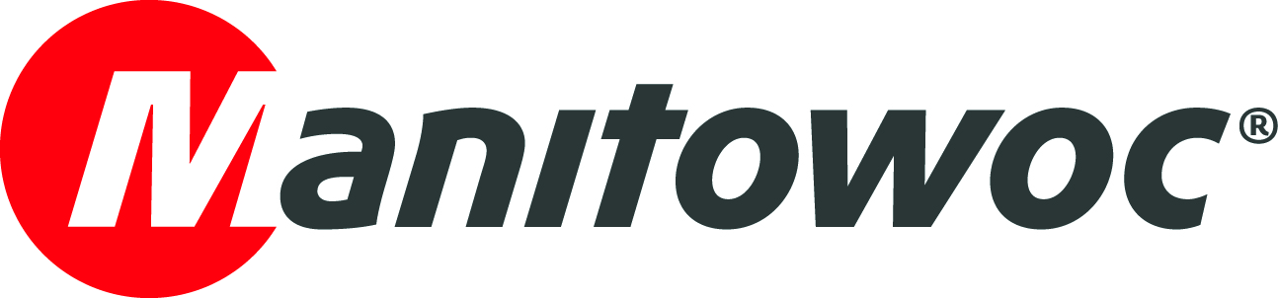
NEWS RELEASE

June 6 2017

Manitowoc expands Scandinavian footprint with new Grove dealership for Norway

- Manitowoc builds on its long-standing relationship with UN Mobilkraner by extending its partnership to Norway.

- UN Mobilkraner’s new branch will be in Drammen, Norway, and will provide Grove sales and service support.

Manitowoc has appointed Danish partner company UN Mobilkraner to be its exclusive mobile crane distributor in Norway. In addition to providing sales and service support for Manitowoc’s Norwegian customers, the move will enable Manitowoc and UN Mobilkraner to continue to build on the strong relationship the two companies have fostered over more than two decades.

“Norway’s construction industry is showing positive signs of growth,” said Niels Hoffman, director of UN Mobilkraner. “In recent years, we’ve seen a rise in residential construction projects and an increase in state spending on roads and railways, so we believe there are many great opportunities for both our business and for Grove cranes and services.”

Manitowoc began working with UN Mobilkraner in 1994, and the Sorring-based company eventually became a Grove distributor in 2010, first for Denmark and then for Sweden. The addition of its new Drammen branch will enable the company to extend its wide range of crane offerings and aftermarket services throughout Norway, and increase its overall reach in Scandinavia.
“UN Mobilkraner has proven itself as a valuable partner in providing Grove crane sales and support across Sweden and Denmark,” explained Steve Barnett, commercial director for Manitowoc in UK, Ireland, Scandinavia and the Baltics. “We have built a strong relationship with the company over the years and we are confident that we will expand upon that success with this new Norwegian venture.”
Established in 1988, UN Mobilkraner specializes in sales and services for new and used Grove cranes. The company currently has branches in Denmark and Sweden, with its new location in Norway opening this spring.
-END-

CONTACT
Andreas Cremer Damian Joseph
Manitowoc SE10
T +49 4421 294 4276 T +1 312 548 8441
andreas.cremer@manitowoc.com damian.joseph@se10.com

ABOUT THE MANITOWOC COMPANY, INC.
Founded in 1902, The Manitowoc Company, Inc. is a leading global manufacturer of cranes and lift solutions with manufacturing, distribution, and service facilities in 20 countries. Manitowoc is recognized as one of the premier innovators and providers of crawler cranes, tower cranes, and mobile cranes for the heavy construction industry, which are complemented by a slate of industry-leading aftermarket product support services. In 2016, Manitowoc’s revenues totaled $1.6 billion, with over half of these revenues generated outside the United States.

THE MANITOWOC COMPANY, INC.

2400 South 44th Street - PO Box 66 - Manitowoc, WI 54221

T +1 920 684 4410
www.manitowoc.com

