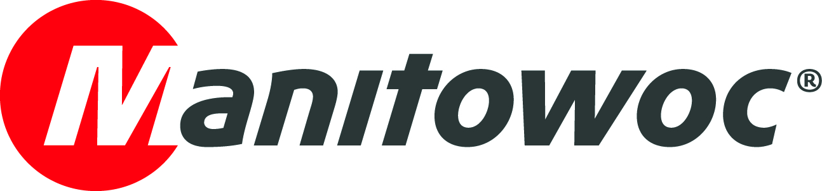
NEWS RELEASE

June 2, 2017

Potain Hup 40-30 makes an award-winning debut in Eastern Europe

- Manitowoc distributor Ferokov exhibited the Potain Hup 40-30 at construction trade fairs in Croatia and Serbia.
- The crane earned an award for the most technologically advanced product at the South East Europe Belgrade Building Expo.

The Potain Hup 40-30 self-erecting crane was shown for the first time at two international building exhibitions in Eastern Europe in April. Prebold, Slovenia-based Manitowoc dealer Ferokov exhibited the crane at the 40th edition of BUILDING, a construction equipment fair in Zagreb, Croatia. And a few weeks later, the company showed the crane at the South East Europe Belgrade Building Expo (SEEBBE) in Belgrade, Serbia.
At SEEBBE the crane garnered a considerable amount of interest and won a “New Vision” award in the category of “Construction Mechanization” for the most technologically advanced product at the exhibition. The prestigious award was presented to Manitowoc in a special ceremony during the show.
“We at Manitowoc are very honored to receive this award from SEEBBE,” said Jean-Pierre Zaffiro, global product director of self-erecting cranes at Manitowoc. “The Hup 40-30 is truly a generational upgrade, reflecting years’ worth of research, design and engineering. Never before have we released a self-erecting crane that gives lifting companies so much flexibility and versatility.”
The 4 t Hup 40-30 features several configuration options, high-performance slewing that delivers superior motion control, and the best transport package ever designed for a self-erecting crane from this category. It can be erected in 16 different configurations, enabling it to be easily adapted for a range of job site applications. Great versatility is delivered with the crane’s raised jib that offers three positions: horizontal, 10° and 20°.
“The Hup 40-30 was a big hit at both of these tradeshows. There were crowds of visitors gathering around to watch it in action during our interactive presentations,” said Enrico Angiolini, sales director for South Europe at Manitowoc. “It was a great opportunity to directly connect with our customers and show them what this crane has to offer.”
Boštjan Krivec, manager, Crane Division at Ferokov, said that the Hup 40-30 is the right crane at the right time for the region, as its construction industry is set to surge.
“Exhibiting a crane with such capabilities as the Hup 40-30 comes at a promising time for the Eastern European construction market, which is gradually gaining pace, thanks in part to EU funding,” he explained. “There are major construction projects happening along the Croatian coastlines and in the Serbian capital, and we feel confident there will be opportunities for a crane as versatile as the Hup 40-30 to increase efficiency on a number of job sites.”
Approximately 9,000 visitors and 146 exhibitors attended BUILDING, which was held at Zagrebački Velesajam in Zagreb, Croatia. In addition to presenting the next-generation Hup 40-30, the exhibition provided an opportunity for Ferokov to introduce visitors to its new Croatian subsidiary, Zagreb-based Ferokov Hrvatska, which launched in March.
In Serbia, more than 36,000 visitors attended SEEBBE, where more than 550 exhibitors from 30 countries displayed new and innovative approaches to construction. Over the course of the five-day event (April 19 – 23), the Ferokov team was accompanied by representatives from its Serbian subsidiary company, Novi Beograd-based K.I.G.O.
Ferokov has been a Manitowoc distributor since December of 2016. Before then, Ferokov traded under the name B&L UTRIP, and has offered sales, rental and service of Potain cranes for the last 25 years.

-END-

CONTACT
Cristelle Lacourt Damian Joseph
Manitowoc SE10
T +33 472 182 018 T +1 312 548 8441
cristelle.lacourt@manitowoc.com damian.joseph@se10.com

ABOUT THE MANITOWOC COMPANY, INC.
Founded in 1902, The Manitowoc Company, Inc. is a leading global manufacturer of cranes and lift solutions with manufacturing, distribution, and service facilities in 20 countries. Manitowoc is recognized as one of the premier innovators and providers of crawler cranes, tower cranes, and mobile cranes for the heavy construction industry, which are complemented by a slate of industry-leading aftermarket product support services. In 2016, Manitowoc’s revenues totaled $1.6 billion, with over half of these revenues generated outside the United States.

THE MANITOWOC COMPANY, INC.

2400 South 44th Street - PO Box 66 - Manitowoc, WI 54221

T +1 920 684 4410
www.manitowoc.com

