NEWS RELEASE

11 September 2017

**Indonesia’s Kokar WIKA orders more Potain MCT 205 cranes**

* *Company now has 24 Potain cranes in its fleet.*

Kokar WIKA has purchased a further four Potain MCT 205 tower cranes over the past 12 months to strengthen its growing rental fleet. The cranes were all ordered through Multicrane Perkasa, Manitowoc’s exclusive dealer for Potain cranes in Indonesia. Prior to this latest order, Kokar WIKA had 20 Potain machines, including a further two MCT 205 units. The MCT 205 is a topless tower crane with a maximum capacity of 10 t and up to 65 m of jib.

Kokar WIKA’s decision to invest in more MCT 205 cranes was heavily influenced by the company’s positive experiences with the model on a range of earlier projects. These include the construction of the TransMart shopping mall in Sidoarjo, Kertajati International Airport in West Java, and the Wisma Atlet Kemayoran, the athletes’ village for the 2018 Asian Games.

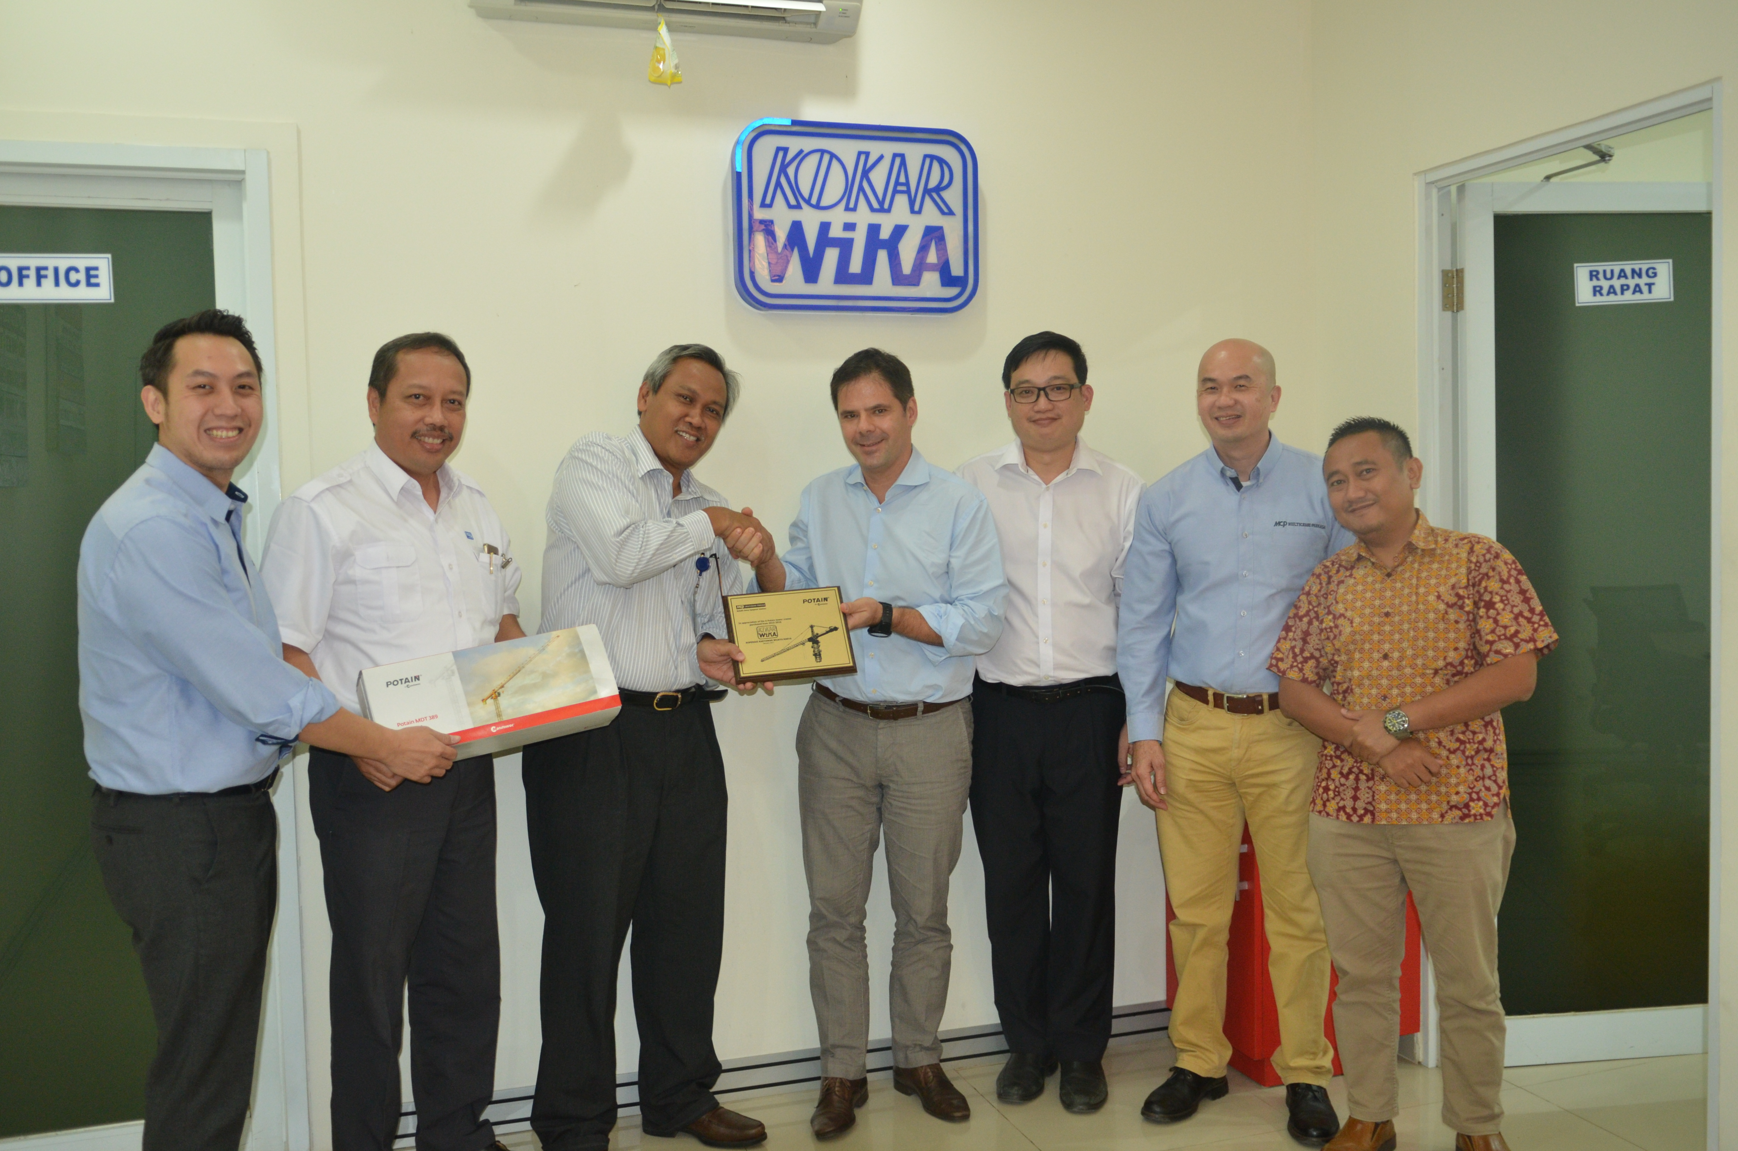

*Celebrating the order from Kokar WIKA for four additional Potain MCT 205 cranes.*

-END-

CONTACT

**Punitha Govindasamy** **Ben Shaw**

Manitowoc SE10

T +65 6263 7863 T +65 6408 3861

[punitha.govindasamy@manitowoc.com](mailto:punitha.govindasamy@manitowoc.com) [ben.shaw@se10.com](mailto:ben.shaw@se10.com)

ABOUT THE MANITOWOC COMPANY, INC.   
Founded in 1902, The Manitowoc Company, Inc. is a leading global manufacturer of cranes and lifting solutions with manufacturing, distribution, and service facilities in 20 countries.  Manitowoc is recognized as one of the premier innovators and providers of crawler cranes, tower cranes, and mobile cranes for the heavy construction industry, which are complemented by a slate of industry-leading aftermarket product support services.  In 2016, Manitowoc’s net sales totaled $1.6 billion, with over half generated outside the United States.

THE MANITOWOC COMPANY, INC.

2400 S. 44th Street - PO Box 66 - Manitowoc, WI 54221, USA

T +1 920 684 4410

[**www.manitowoc.com**](http://www.manitowoccranes.com/)**­**