NEWS RELEASE

September 5, 2017

**RIMASA adds more Potain cranes to meet growing demand**

* *Company has added 10 new cranes over the past 12 months.*

Indonesia’s PT. Tanjungsari Prima Sentosa (RIMASA) has placed a second order for Potain cranes after receiving its first cranes from the company last year. This latest order was placed through Multicrane Perkasa, Manitowoc’s exclusive dealer for Potain cranes in the country. The order for four new MCT 205 cranes means RIMASA has now ordered 10 new Potain cranes over the past 12 months, all MCT 205 or MC 310 K12 models.

The 10 t capacity MCT 205 has a maximum freestanding height of 59.4 m on its P20 A fixing angles and can lift up to 1.75 t at its jib end of 65 m. RIMASA currently has Potain cranes working on the construction of the Jakarta International Velodrome in Rawamangun as part of the development work for the 2018 Asian Games. Other Potain cranes from the company are working on the parking structure of the World Trade Center Surabaya in Indonesia.

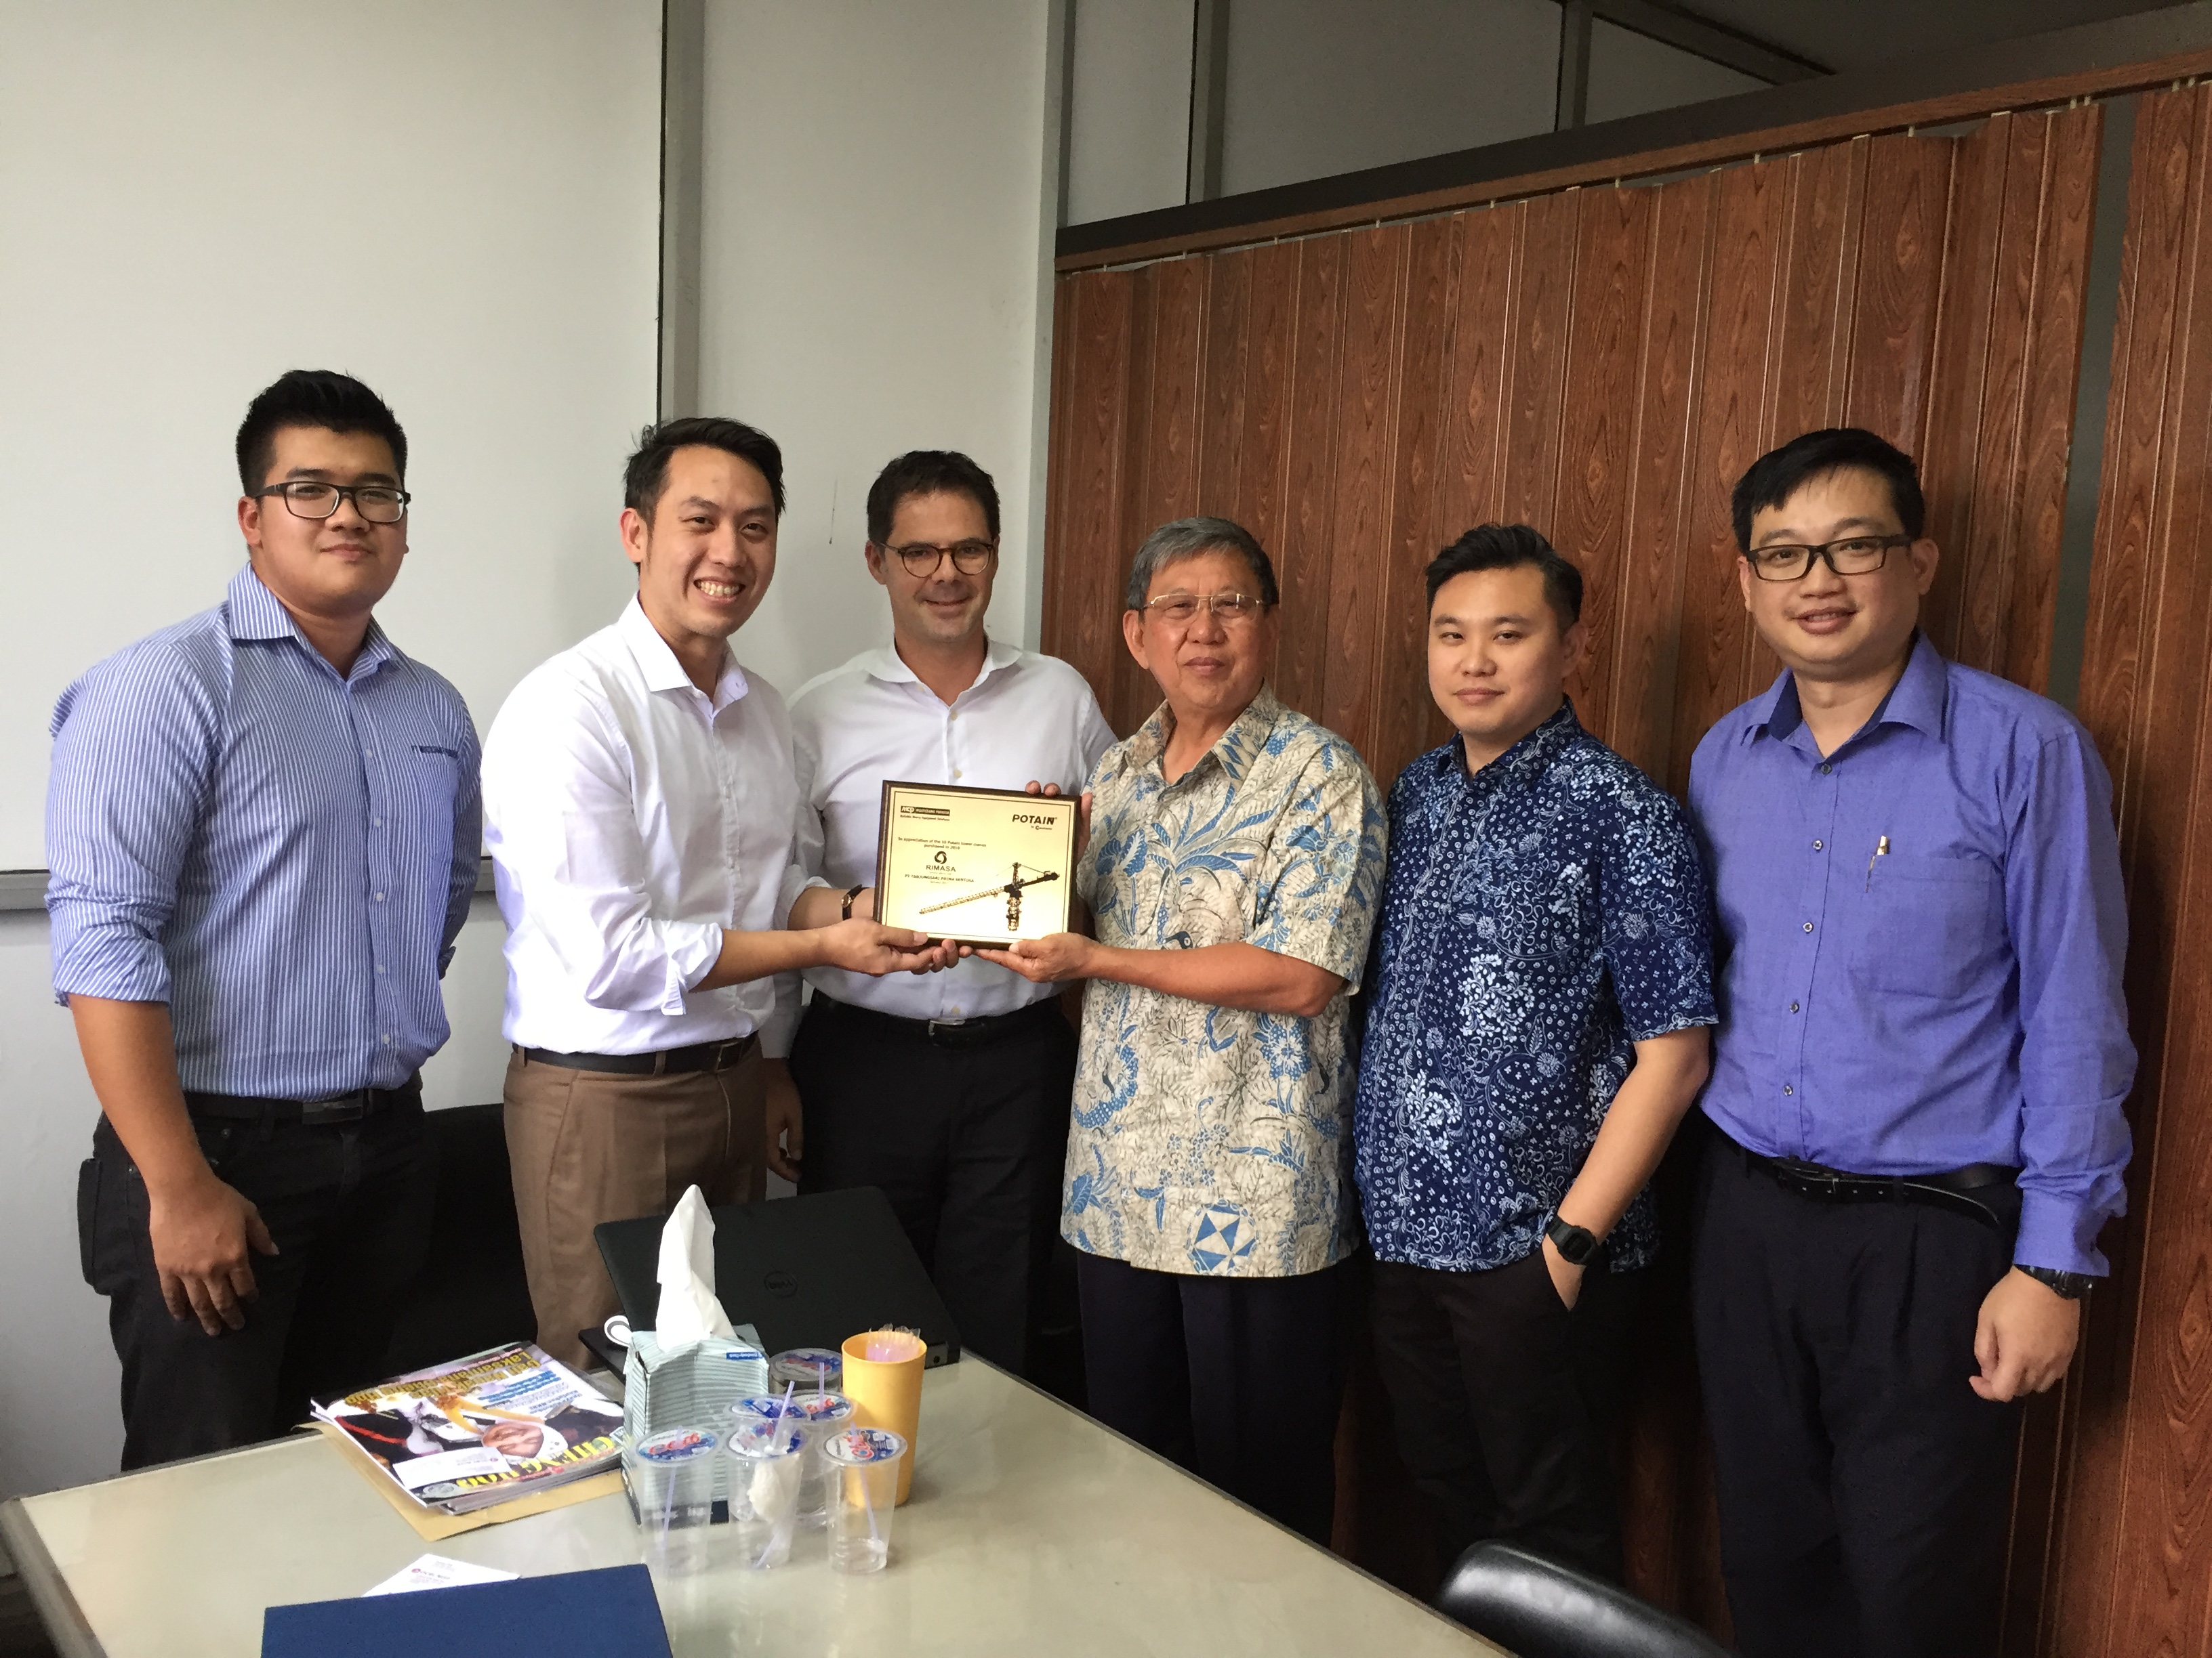

*Staff from RIMASA, Multicrane Perkasa and Manitowoc celebrate an order for four new Potain MCT 205 cranes.*

-END-

CONTACT

**Punitha Govindasamy** **Ben Shaw**

Manitowoc SE10

T +65 6263 7863 T +65 6408 3861

[punitha.govindasamy@manitowoc.com](mailto:punitha.govindasamy@manitowoc.com) [ben.shaw@se10.com](mailto:ben.shaw@se10.com)

ABOUT THE MANITOWOC COMPANY, INC.   
Founded in 1902, The Manitowoc Company, Inc. is a leading global manufacturer of cranes and lifting solutions with manufacturing, distribution, and service facilities in 20 countries.  Manitowoc is recognized as one of the premier innovators and providers of crawler cranes, tower cranes, and mobile cranes for the heavy construction industry, which are complemented by a slate of industry-leading aftermarket product support services.  In 2016, Manitowoc’s net sales totaled $1.6 billion, with over half generated outside the United States.

THE MANITOWOC COMPANY, INC.

2400 S. 44th Street - PO Box 66 - Manitowoc, WI 54221, USA

T +1 920 684 4410

[**www.manitowoc.com**](http://www.manitowoccranes.com/)**­**