NEWS RELEASE

6 September 2017

**Potain cranes go to work on South Korean LNG terminal**

* *Cranes help to build three storage tanks with a capacity of 200 million liters each.*

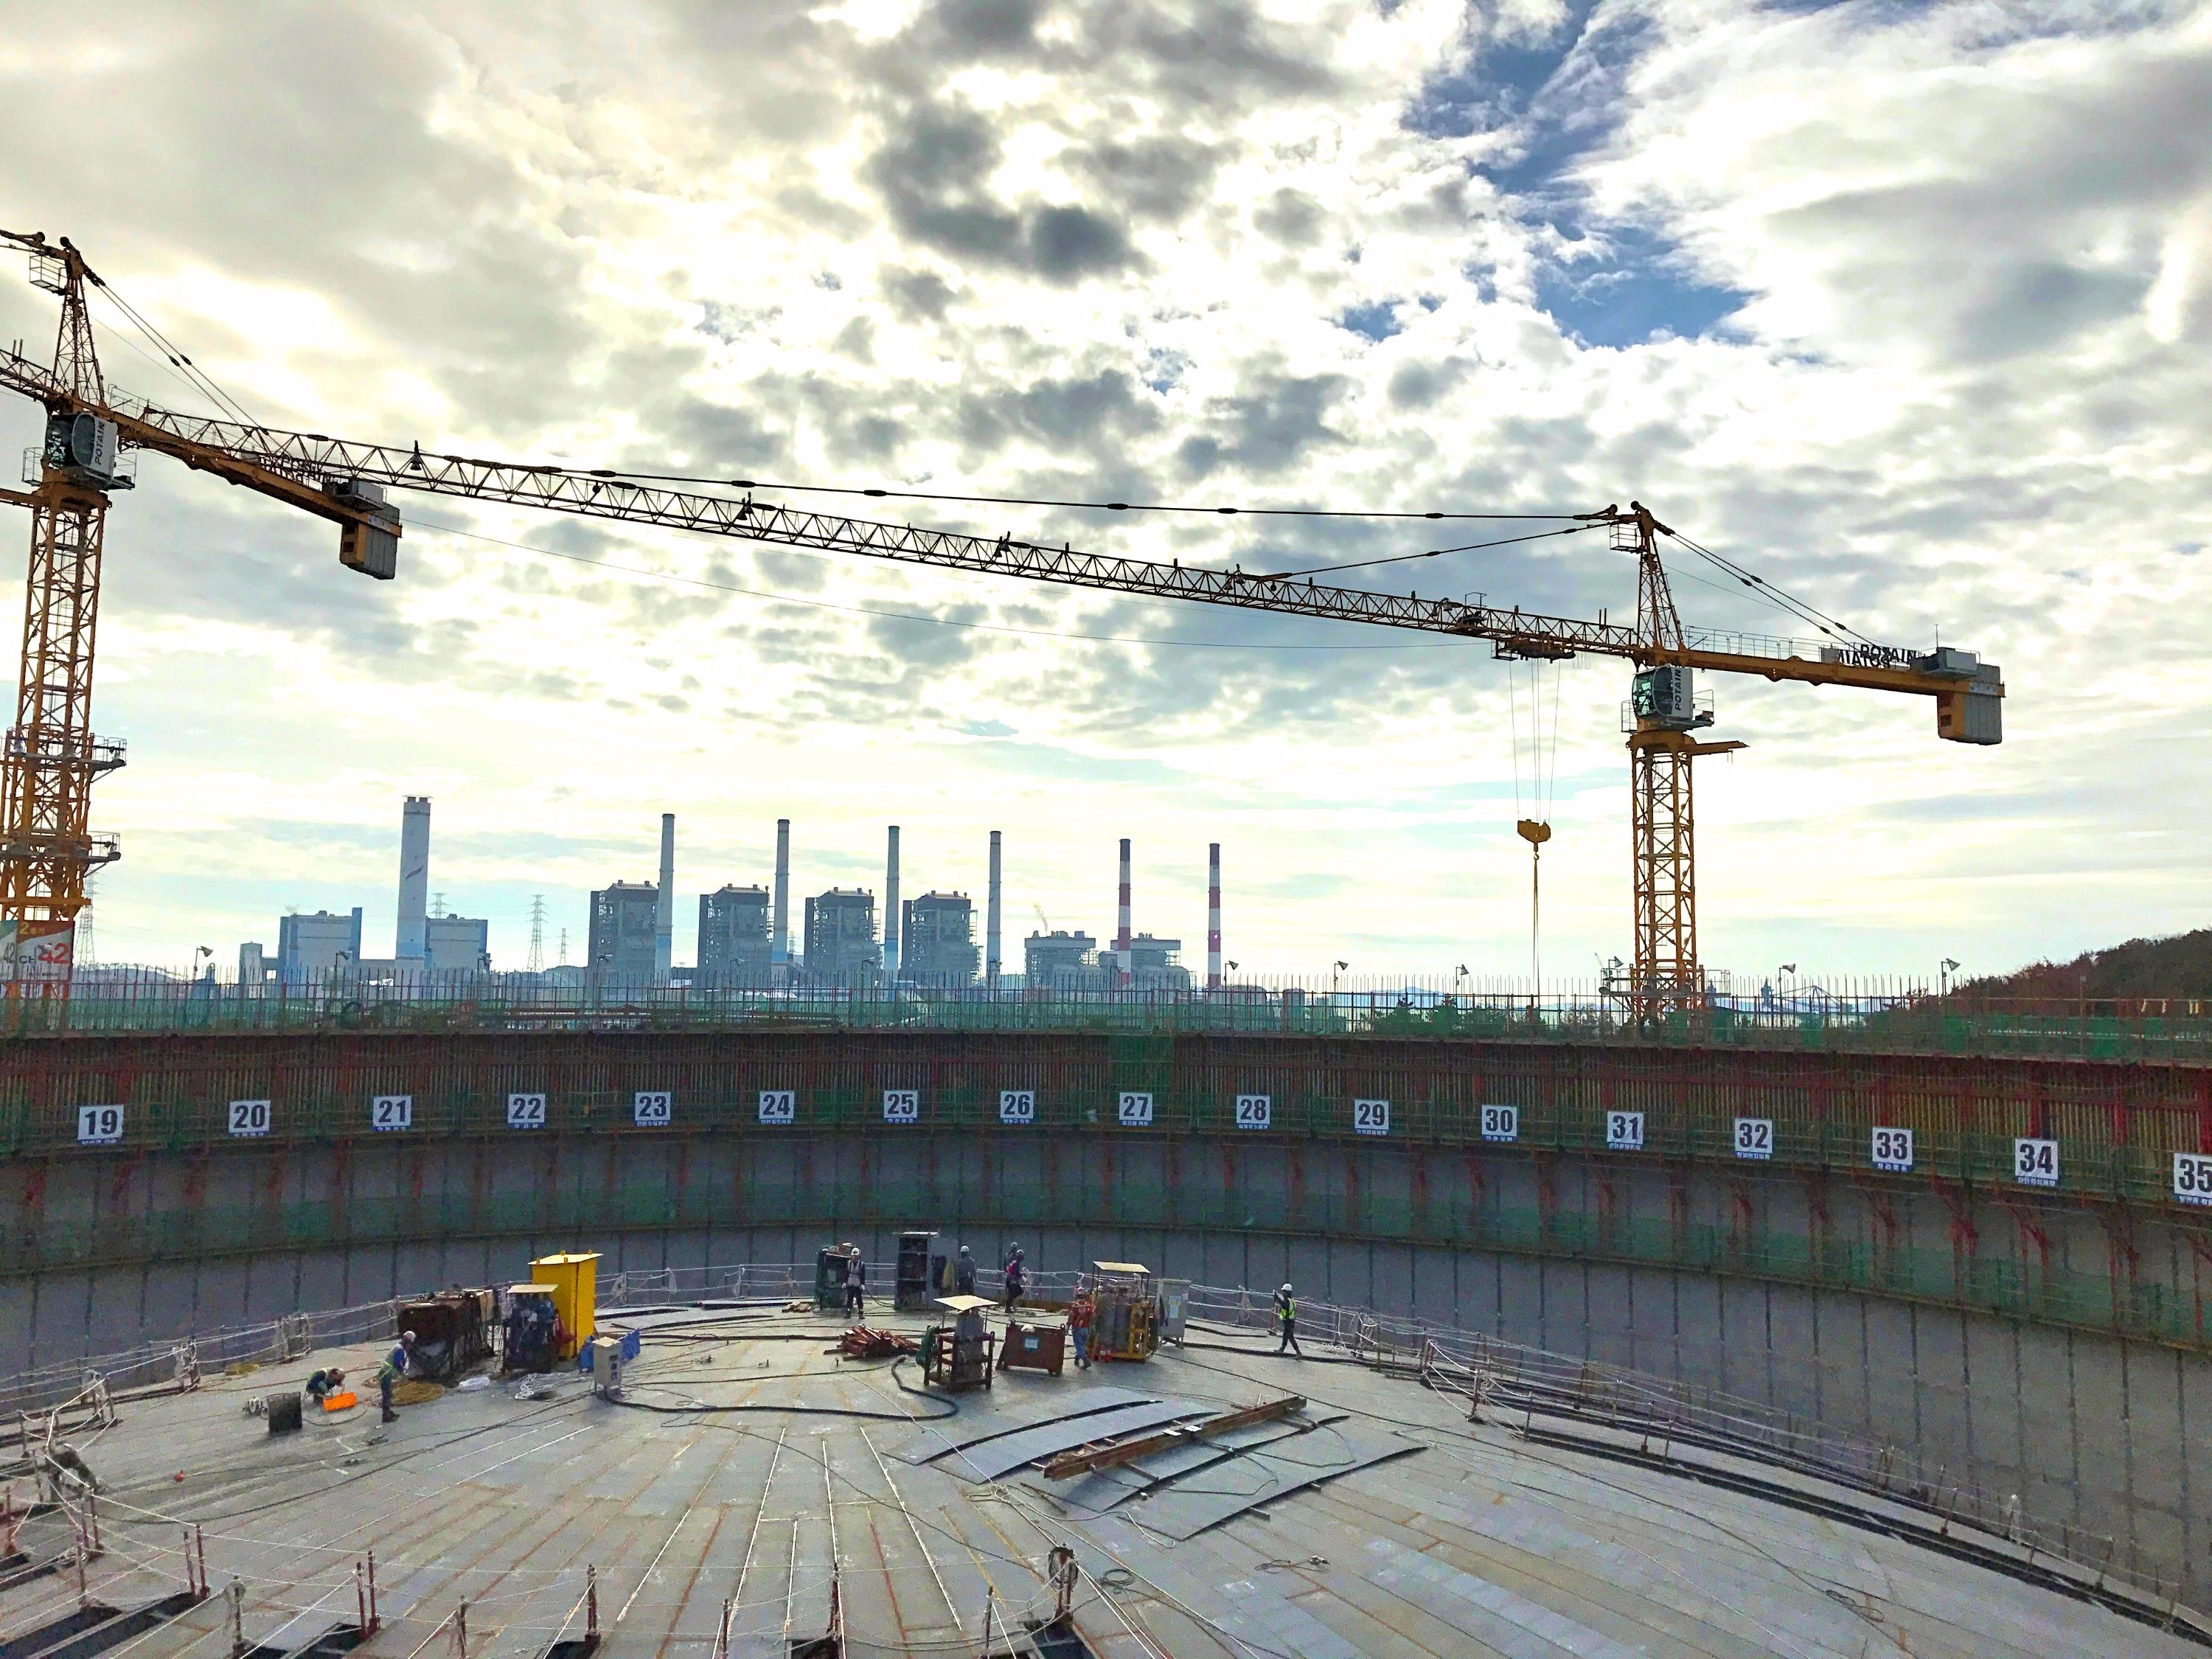South Korean construction equipment rental company Sunheung Corporate has supplied three Potain MC 310 K12 cranes to work on a liquefied natural gas (LNG) tank at the Boryeong LNG Terminal. Located inside the Yeongbo Industrial Zone in Boryeong, the terminal is co-owned by SK E&S and GS Energy. When completed, it will feature three LNG storage tanks with a capacity of 200 million liters each. There will also be a 45,000 t liquefied petroleum gas tank and a re-gasification plant inside the facility.

The MC 310 K12 has a maximum capacity of 12 t, a maximum radius of 70 m and can lift up to 3.2 t at its jib end. The cranes were supplied to Sunheung Corporate by Korea International Limited (KIL), the exclusive Potain distributor for South Korea.

-END-

CONTACT

**Punitha Govindasamy** **Ben Shaw**

Manitowoc SE10

T +65 6263 7863 T +65 6408 3861

[punitha.govindasamy@manitowoc.com](mailto:punitha.govindasamy@manitowoc.com) [ben.shaw@se10.com](mailto:ben.shaw@se10.com)

ABOUT THE MANITOWOC COMPANY, INC.

Founded in 1902, The Manitowoc Company, Inc. is a leading global manufacturer of cranes and lifting solutions with manufacturing, distribution, and service facilities in 20 countries. Manitowoc is recognized as one of the premier innovators and providers of crawler cranes, tower cranes, and mobile cranes for the heavy construction industry, which are complemented by a slate of industry-leading aftermarket product support services. In 2016, Manitowoc’s net sales totaled $1.6 billion, with over half generated outside the United States.

THE MANITOWOC COMPANY, INC.

2400 S. 44th Street - PO Box 66 - Manitowoc, WI 54221, USA

T +1 920 684 4410

[**www.manitowoc.com**](http://www.manitowoccranes.com/)**­**