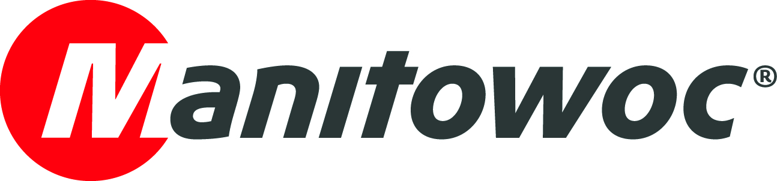
NEWS RELEASE
April 5, 2017

Major Middle East shipbuilder chooses Grove cranes

- First Grove crane purchases for Suez Shipyard Company
- Company impressed with Manitowoc’s manufacturing quality and unique Product Verification Centers
- New additions will help with maintenance duties at Egyptian facility

Suez Shipyard Company has purchased two new Grove all-terrain cranes, a Grove GMK5130-2 and a GMK4080-1, through Orascom Trading, the Manitowoc dealer for Egypt. These new additions mean the facility now has seven mobile cranes, with the latest deliveries being the company’s first Manitowoc-made units. The Egyptian shipbuilder is one of the most celebrated in the region, with its facilities boasting the largest floating dock in the Middle East, as well as its oldest graving dock.

The two new cranes will boost the company’s in-house fleet and reduce its reliance on rental cranes. Essam Dabash, chairman of Suez Shipyard, was among a delegation from the company that traveled to the Manitowoc factory in Wilhelmshaven, Germany, to collect the cranes.

He said that while Manitowoc already has a good reputation in Egypt, seeing the company’s factory—and especially the Product Verification Center (PVC)—gave him true confidence in the cranes it produces. The PVC provides sophisticated component-level and full-vehicle testing to verify designs and durability early in product development processes. This enables Manitowoc to launch new models faster, as well as reducing warranty and field issues.

“The tour of Wilhelmshaven and the PVC was eye opening and we could understand the capabilities of Manitowoc and its determination to build first-class machines,” said Essam Dabash. “Efficiency is essential to our own operations so we wanted to buy cranes that have excellent customer support and to which our operators will easily adapt. With these new Grove cranes we are confident on both these points.”

Suez Shipyard Company will use the GMK5130-2 around its floating dock for general maintenance duties. The 130 t capacity crane is a successor to the popular GMK5130-1 and is powered by an eight-cylinder, turbo-charged Mercedes-Benz OM 502 LA engine. It also has an improved cab over its predecessor that includes an ability to hydraulically tilt up to 20°. The Twin-Lock boom extends from 12.9 m to 60 m in six sections and its maximum tip height is 92 m when working with jib extensions.

The company will use the flexible GMK4080-1 to support general maintenance duties and lifting tasks around the yard’s various workshops. The 80 t capacity, four-axle all-terrain crane features a 290 kW Mercedes engine that provides smooth and consistent power both on- and off-road. The machine is equipped with a 51 m, six-section Twin-Lock boom that can be extended to 82 m through the addition of jib sections.

Waleed Raouf, Manitowoc’s regional sales manager for mobile and crawler cranes, was delighted to deliver the first Grove cranes to such a prestigious Middle Eastern industrial facility.

“Suez Shipyard Company is a world-class operation, so we are very proud to supply the first Grove cranes to the company,” he said. “We hope these are the first of many, and I’m sure these two additions will bring tremendous efficiency to its maintenance operations and day-to-day activities.”

Based in Egypt, Suez Shipyard Company was established in 1862 and specializes in shipbuilding and repair. Located at the southern mouth of the Suez Canal, the company has built a wide range of ships, including bulk and general cargo vessels, as well as LPG carriers and offshore rigs.

-END-

CONTACT
Punitha Govindasamy Ben Shaw
Manitowoc SE10
T +65 6263 7863 T +65 6408 3861
Punitha.Govindasamy@manitowoc.com ben.shaw@se10.com

ABOUT THE MANITOWOC COMPANY, INC.
Founded in 1902, The Manitowoc Company, Inc. is a leading global manufacturer of cranes and lift solutions with manufacturing, distribution, and service facilities in 20 countries. Manitowoc is recognized as one of the premier innovators and providers of crawler cranes, tower cranes, and mobile cranes for the heavy construction industry, which are complemented by a slate of industry-leading aftermarket product support services. In 2016, Manitowoc’s revenues totaled $1.6 billion, with over half of these revenues generated outside the United States.

THE MANITOWOC COMPANY, INC.
2400 S. 44th Street - PO Box 66 - Manitowoc, WI 54221, USA
T +1 920 684 4410
www.manitowoc.com

