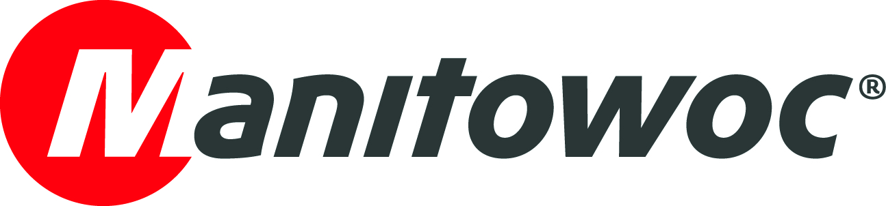
NEWS RELEASE
April 19, 2017

First Potain Hup cranes in Australia go to Active Crane Hire

- Two Hup 32-27 self-erecting cranes have been delivered to a Potain business partner and major Australian crane supplier.
- The cranes’ flexible configuration options are especially suited to residential construction work in New South Wales.

The first two Potain Hup self-erecting cranes in Australia have been delivered to Active Crane Hire of NSW and immediately put to work on a residential development project in Ryde, a Sydney suburb. The cranes are assisting in the construction of a seven-story apartment building and were chosen for their compact footprints and versatile configuration options, which make them ideal for such urban, low-rise construction projects.

Hermann Buchberger, managing director of the Somersby-based company, said the design of the Hup 32-27, and particularly its flexible mast system, will enable the company to use the crane in a variety of scenarios on the job site. The crane features an adjustable two-section mast with a third section within the second. This allows the third mast section to be telescoped out, boosting its working height to 27 m.

“Unlike most cranes used for low-rise construction, the Hup 32-27 has a 27 m working height, meaning it fits above the local tree line, which tends to be around 21 m,” he explained. “It’s also compact enough that if we need to install it underneath a tower crane on an existing site, we can do that. This eliminates the need to rearrange cranes on site.”

The Hup 32-37 has a maximum capacity of 4 t, and can lift 1 t at its jib end of 32 m. It has a rear-slewing radius of only 2.25 m, enabling it to be positioned closer to buildings. Despite being taller than the Igo 36, one of its predecessor models, the Hup 32-27 occupies the same footprint, making it ideal for space-restricted job sites. Its two footprint options, 4 m x 4 m or 3.5 m x 4.42 m, and an innovative unfolding movement mean the crane can set up in even the most congested spaces.

The Hup 32-27 debuted in mid-2016 and has already begun popping up on job sites around the world. The goal of the Hup design is to deliver improved versatility and agility to customers, which helps them increase their return on investment. In particular, the crane’s wide variety of configurations and ease of erection help achieve this.

Three raised positions of the luffing jib, at 10◦, 20◦ or 30◦, in addition to horizontal, provide unprecedented options for a self-erecting crane. To maximize operator efficiency, the crane has a new radio remote control with a large color screen and easy-to-use navigation (via jog dial). New Smart Set Up software displays unique and simple on-screen, step-by-step information during erection.

“The Hup fills a gap between large self-erecting cranes and small tower cranes. It is small and flexible enough to handle construction work for four-story to seven-story developments,” Buchberger explained. “It’s more user-friendly than the alternatives and the commissioning is faster, which saves us time and money.”

Active Crane Hire is a Potain business partner, based in Somersby, New South Wales. It is one of the largest tower crane rental companies in Australia, with a fleet of both top-slewing tower cranes and self-erecting cranes.

-END-

CONTACT
Punitha Govindasamy Ben Shaw
Manitowoc SE10
T +65 6263 7863 T +65 6408 3861
punitha.govindasamy@manitowoc.com ben.shaw@se10.com

ABOUT THE MANITOWOC COMPANY, INC.
Founded in 1902, The Manitowoc Company, Inc. is a leading global manufacturer of cranes and lift solutions with manufacturing, distribution, and service facilities in 20 countries. Manitowoc is recognized as one of the premier innovators and providers of crawler cranes, tower cranes, and mobile cranes for the heavy construction industry, which are complemented by a slate of industry-leading aftermarket product support services. In 2016, Manitowoc’s revenues totaled $1.6 billion, with over half of these revenues generated outside the United States.

THE MANITOWOC COMPANY, INC.
2400 S. 44th Street - PO Box 66 - Manitowoc, WI 54221, USA
T +1 920 684 4410
www.manitowoc.com

