NEWS RELEASE

January 19, 2016

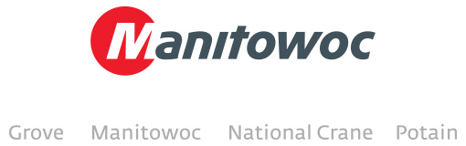

**Manitowoc Cranes pre-bauma press kit now available for download**

Ready for download from Manitowoc Cranes’ [website](http://www.manitowoccranes.com/en/news-events/news) is the company’s 2016 pre-bauma press kit.

Several press releases that detail what the company will be showing at its bauma booth, as well as high-resolution images and logistical information are available here:

<http://www.manitowoccranes.com/en/news-events/news>

Please join Manitowoc Cranes at bauma 2016, April 11 – 17, in Munich, Germany, at stands 1201, 1202 and 1301/2.

-END-

CONTACT

**Cristelle Lacourt** **Charlie Ebers**

Manitowoc SE10

T +33 472 182 018 T +44 207 923 5864

[cristelle.lacourt@manitowoc.com](mailto:cristelle.lacourt@manitowoc.com) [charlie.ebers@se10.com](mailto:charlie.ebers@se10.com)

ABOUT THE MANITOWOC COMPANY, INC.   
Founded in 1902, The Manitowoc Company, Inc. is a multi-industry, capital goods manufacturer with 92 manufacturing, distribution, and service facilities in 25 countries. The company is recognized globally as one of the premier innovators and providers of crawler cranes, tower cranes, and mobile cranes for the heavy construction industry. Manitowoc is also one of the world's leading innovators and manufacturers of commercial foodservice equipment, which includes 24 market-leading brands of hot- and cold-focused equipment. In addition, both segments are complemented by a slate of industry-leading product support services. In 2014, Manitowoc’s revenues totaled $3.9 billion, with approximately half of these revenues generated outside of the United States.

MANITOWOC CRANES

2401 South 30th Street - PO Box 70 - Manitowoc, WI 54221-0070

T +1 920 684 6621

[**www.manitowoccranes.com**](http://www.manitowoccranes.com)**­**