NEWS RELEASE

December 15, 2016

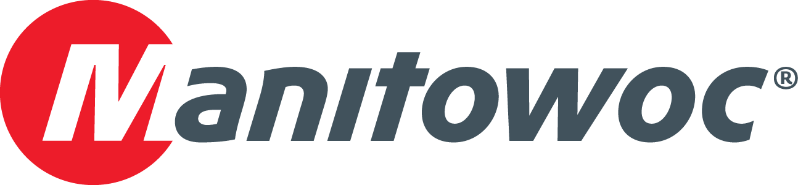

**Grove GHC75 brings pile-driving efficiency to Arkansas park restoration**

* *Arco Excavation & Paving used a Grove GHC75 telescoping crawler crane to build an elevated retaining wall during a park restoration project in Rogers, Arkansas.*
* *The GHC75’s expandable, heavy-duty crawler tracks eliminated the need for deploying outriggers, which enabled the crane to maneuver in tight quarters over wet, uneven terrain.*
* *The intuitive and user friendly Rated Capacity Limiter, which displays operating parameters, enabled contractors to lift more efficiently during construction.*

In Rogers, Arkansas, a Grove GHC75 telescoping crawler crane played a pivotal role in a project to rehabilitate a long-neglected city park, enabling contractors to rebuild the park’s infrastructure amid tight quarters and challenging terrain.

Lake Atalanta Park closed in mid-2015 to undergo renovations after years of deterioration. A crucial component of the park’s rehab took place in August and involved building an elevated retaining wall in difficult job site conditions. Construction called for piles to be driven in the wet, uneven soil of a creek bed, and the job site only allowed for a 30 ft radius for contractors to work in.

Arco Excavation & Paving was the contractor tasked with building the retaining wall. The Bentonville, Arkansas-based company chose a Grove GHC75 to perform the pile-driving portion of the project for its maneuverability and ease of use. The crane’s crawler tracks enabled it to easily maneuver on the creek bed, while its telescoping boom gave the company flexibility in lifting and carrying loads.

Mike Snook, who worked for Arco as the foreman on the project, had never worked with a telescoping crawler crane before this job. After discovering the GHC75, though, he was confident that he could handle the pile-driving without using a much larger crane, saving time and money on the job.

“I’ve got 20 years of excavation experience,” he said. “But driving piles with a telescoping crawler crane was relatively new to me. I went to the rental yard thinking I would be coming back with a larger lattice boom crane, but the Grove GHC75 was better suited for this type of project. It had the crawler tracks to maneuver with and a compact footprint that could fit on this job site.”

The GHC75’s controls were not a challenge for Snook, either. The Rated Capacity Limiter with graphical display was easy to use, providing all the necessary operating parameters and advanced, real-time diagnostics. When combined with the crane’s load chart, Snook found that he could quickly set up his lifts with even more confidence than usual.

“Even after reviewing the load chart to prepare for each lift, this crane had more to teach me as I went along,” he explained. “It told me what I could and couldn’t pick up in real-time and assisted me in making adjustments before each lift. I was trying to avoid lifting at 70 percent of my load, and the in-cab display made it easier for me to stay between 40 and 60 percent.”

The 75 USt GHC75 drove approximately 40 H-beam piles into the creek bed using an 8.5 USt diesel pile hammer—the height was 93 ft for each pile. The crane also picked and set 10 ft x 10 ft drainage boxes that weighed 15 USt each, as well as 15 ft x 21 ft trench boxes that weighed 7.5 USt each. The crane’s full power hydraulic boom allowed for the telescoping of loads from 36 ft to 118 ft, which ensured that all lifts could be quickly and precisely moved in tight quarters.

The crane’s exceptional maneuverability played an equally important role to its controls. The three-position, hydraulically extendable undercarriage—which adjusts the width of the crawler’s tracks by moving them inward or outward from the crane’s center—provided maximum flexibility on the job, enabling Snook to perform heavy lifts in a small, uneven space. In addition, the cranes 100% pick-and-carry capabilities allowed the crane to quickly move around on the jobsite since no outriggers were needed.

“We were working in very tight quarters on that creek bed,” he said. “We also had to contend with cars driving past all day long—there was no room to set up the outriggers you find on a more traditional hydraulic crane. With the GHC75, I was able to drive right into place, spread the tracks out all the way and perform the lift.”

Arco rented the crane from Kirby-Smith Machinery, which has been a leading distributor of heavy equipment and cranes in the central U.S. for more than 30 years. The Oklahoma City-based company serves a wide array of industries from its 10 full-service locations, including construction, paving, industrial, aggregate, pipeline services and many others.

“I’m happy to say that this crane performed unbelievably well. In fact, when I showed my contracting mentor of 45 years what the GHC75 could do, he called it the ‘Cadillac of cranes,’” Snook said.

Arco Excavation & Paving is a fully licensed and insured contractor that specializes in site development, paving, demolition, excavation, snow removal and various other services. Since 2004, the Bentonville, Arkansas-based company has served Northwest Arkansas and its surrounding areas with dependable service, delivering projects on time and within budget.

The pile-driving portion of the project was completed in August of 2016, allowing renovation of Lake Atalanta Park to stay on track for its October deadline. After 16 months of construction, the locally beloved park reopened on Saturday, October 29th.

-END-

CONTACT

**Amy Marten** **Damian Joseph**

Manitowoc SE10

T +1 920 683 6345 T +1 312 548 8441

[amy.marten@manitowoc.com](mailto:amy.marten@manitowoc.com) [damian.joseph@se10.com](mailto:damian.joseph@se10.com)

ABOUT THE MANITOWOC COMPANY, INC.   
Founded in 1902, The Manitowoc Company, Inc. is a leading global manufacturer of cranes and lift solutions with manufacturing, distribution, and service facilities in 20 countries. Manitowoc is recognized as one of the premier innovators and providers of crawler cranes, tower cranes, and mobile cranes for the heavy construction industry, which are complemented by a slate of industry-leading aftermarket product support services. In 2015, Manitowoc’s revenues totaled $1.9 billion, with over half of these revenues generated outside of the United States.

MANITOWOC CRANES

2401 South 30th Street - PO Box 70 - Manitowoc, WI 54221-0070

T +1 920 684 6621

[**www.manitowoc.com**](http://www.manitowoc.com)**­**