NEWS RELEASE

January 19, 2017

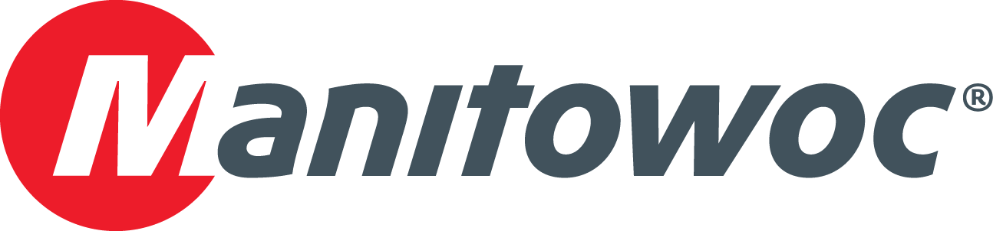

**Grove GHC75 helps construct Skyway Bridge, Colorado’s longest elevated railway**

* *Construction of the Skyway Bridge has commenced in Denver, Colorado, and a Grove GHC75 has helped construct the project’s most difficult stretch.*
* *The GHC75 doesn’t need to be set up on outriggers, which enabled contractors to work in tight quarters while saving almost 20 minutes in setup time per lift.*
* *With its expandable, heavy-duty crawler treads and 100 percent pick-and-carry capability, the GHC75 offered the manueverability to navigate the job site’s uneven terrain.*

In Denver, Colorado, a massive new infrastructure project is underway. The North Metro Rail Line is an 18.5-mile electric commuter rail system that will connect Denver’s Union Station with many of the city’s northern suburbs. Ten miles of the track have been completed so far, along with six of the train line’s eight stations.

A notable portion of the project is the Skyway Bridge, an elevated light rail bridge that will measure 1.8 miles in length, making it the longest of its kind in Colorado. Though construction of the Skyway Bridge will extend into 2017, one of the most difficult phases of the project has already been completed: a stretch of bridge that runs in between the properties of an oil refinery and a large wastewater treatment plant, which provided little space for a crane to maneuver.

Ralph L. Wadsworth Construction Company (RLW) is the contractor tasked with building the Skyway Bridge. The company rented a Grove GHC75 for the project, as the telescoping crawler crane was one of few machines that could navigate the job site’s tough conditions.

Lee Adams, construction manager for RLW, said that the maneuverability of the GHC75, along with its compact footprint, was crucial in completing construction. Adjacent (pre-existing) railroad tracks and a water-filled canal constrained space at one point on the job site, and on another, a retaining wall and fence flanked the skyway’s path.

“There was a very narrow alleyway to work with in between the two properties—it was a tight space that offered little more than the width of the train tracks themselves,” he explained. “There wouldn’t have been room for a standard, outrigger-equipped hydraulic crane. The GHC75 gave us the capacity we needed in a frame that was small and agile enough to traverse the narrow job site.”

The 118 ft 1 in telescoping boom of the GHC75—which enables it to pick-and-carry at 100 percent of its load chart and to swing loads a full 360 degrees—also came in handy on the project. Combined with the crane’s ability to travel over rough terrain with its crawler tracks, the 75 USt GHC75 was able to complete some very challenging pick-and-carry lifts.

“First we had to drive the crane over a railroad crossing and down beneath power lines to get it in position for the lifts,” Adams said. “Then we needed to pick up a load, boom down and navigate beneath the power lines without a hitch to place the load. This really was the perfect crane for this situation.”

The GHC75 lifted 9 USt concrete gang forms to a height of 40 ft, which enabled workers to bolt the forms together in an interlocking formation to construct the elevated bridge. The crane also hoisted 16 USt rebar cages to heights of 72 ft and released concrete on top of pier caps using a bucket system.

The maneuverability of the GHC75 was not lost on Zach Beckwith, the foreman and crane operator on the job site, who praised the crane’s versatility and ease of use.

“This crane was perfect for the job since we didn’t have to worry about the outriggers you find on a traditional hydraulic crane,” he said. “If you have to move a regular hydraulic crane, you have to suck the boom in, break down the outriggers, move the pads and start all over with the next lift. The GHC75’s heavy duty crawler treads enabled us to simply move into place and get to work, saving almost 20 minutes per lift.”

RLW rented the GHC75 from Denver, Colorado-based Honnen Equipment, with which RLW has had a long-standing relationship. Honnen Equipment has been providing sales and rentals of construction equipment and cranes since 1963. The family-owned company offers the full line of Manitowoc-branded cranes from its 10 locations across the Rocky Mountains region, which includes Colorado, Wyoming, Idaho and Utah.

“Without the GHC75, we might have had to rent a much larger one from Honnen—something like a 500 USt crawler,” Adams said. “That would have put us on the other side of the canal due to the space. It would have been much more expensive and much more difficult to quickly complete these precision lifts. The savings of time and money are considerable when you think about the alternative.”

Overall construction of the North Metro Rail Line began in October of 2015, and is on track for completion in fall of 2017. The $350 million project will run from Denver’s Union Station through Commerce City, Thornton and Northglenn to Highway 7 in North Adams County, utilizing eight stops along the route.

RLW was founded in 1975 and is now run by the second generation of Wadsworths. The Draper, Utah-based firm, which now has a division office in Thornton, Colorado, has worked on several multi-million dollar projects throughout the Intermountain West region of the U.S., specializing in design-build, construction management and traditional design-bid-build projects.

-END-

CONTACT

**Amy Marten** **Damian Joseph**

Manitowoc SE10

T +1 920 683 6345 T +1 312 548 8441

[amy.marten@manitowoc.com](mailto:amy.marten@manitowoc.com) [damian.joseph@se10.com](mailto:damian.joseph@se10.com)

ABOUT THE MANITOWOC COMPANY, INC.   
Founded in 1902, The Manitowoc Company, Inc. is a leading global manufacturer of cranes and lift solutions with manufacturing, distribution, and service facilities in 20 countries. Manitowoc is recognized as one of the premier innovators and providers of crawler cranes, tower cranes, and mobile cranes for the heavy construction industry, which are complemented by a slate of industry-leading aftermarket product support services. In 2015, Manitowoc’s revenues totaled $1.9 billion, with over half of these revenues generated outside of the United States.

MANITOWOC CRANES

2401 South 30th Street - PO Box 70 - Manitowoc, WI 54221-0070

T +1 920 684 6621

[**www.manitowoc.com**](http://www.manitowoccranes.com/)**­**