NEWS RELEASE

August 16, 2016

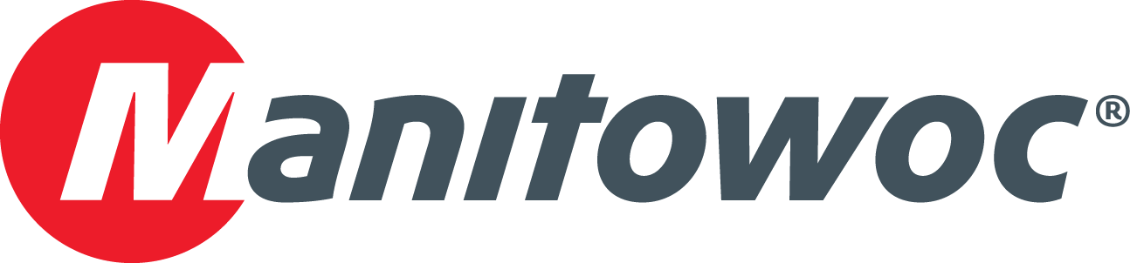

**DCH Crane adds mobility and versatility to its fleet with Grove GMK5250L**

DCH Crane has taken delivery of a Grove GMK5250L in a move to enhance the mobility of its fleet. The St. John’s, Newfoundland, Canada-based company acquired the crane in May of 2016 and immediately put it to work to assist with several of its offered services, including lifting, rigging, heavy haul transport and general maintenance.

“We were looking for a crane that could meet 80 percent of our capacity needs, but we still needed to remain in the five-axle class because of regional weight restrictions,” said Dwayne Murphy, manager at DCH Crane. “The GMK5250L suits our needs – it’s powerful for its size and gives us the mobility we need to efficiently service our ongoing work.”

Upon its release in 2015, the 300 USt capacity GMK5250L was the first ever mobile crane to feature the VIAB turbo clutch module, which eliminates fluid overheating and clutch burning as it delivers improved fuel economy. The VIAB module also enables class-leading maneuverability and driver comfort by working in tandem with the crane’s integrated retarder, resulting in wear-free braking and starting.

Other features on the GMK5250L include interchangeable counterweight slabs, a self-rigging auxiliary hoist and a 230 ft main boom that offers a stronger reach and load chart than many competing five-axle cranes.

DCH purchased the GMK5250L from Shawmut Equipment, a crane dealer that has served New England and the Atlantic provinces of Canada since 1957. The Manchester, Connecticut-based company is one of Manitowoc’s leading distributors in the Northeast and is a third-generation family-owned business, earning consistently high marks on independent customer surveys.

“Our experience with Manitowoc has been consistently excellent, and dealing with Shawmut Equipment is a big part of that,” Murphy said. “Shawmut suggested the GMK5250L for our specific needs and we couldn’t be happier with the result. We’ve been working with them since 2009 because the service never falters and they always go to bat for us, which is why we keep going back.”

DCH Crane is a locally owned and operated crane and transport company that has served the province of Newfoundland and Labrador for more than 30 years. DCH offers services in numerous industries, including oil and gas, wind energy and construction.

-END-

CONTACT

**Amy Marten** **Damian Joseph**

Manitowoc SE10

T +1 920 683 6345 T +1 312 548 8441

[amy.marten@manitowoc.com](mailto:amy.marten@manitowoc.com) [damian.joseph@manitowoc.com](mailto:damian.joseph@se10.com)

ABOUT THE MANITOWOC COMPANY, INC.

Founded in 1902, The Manitowoc Company, Inc. is a leading global manufacturer of cranes and lift solutions with manufacturing, distribution, and service facilities in 20 countries. Manitowoc is recognized as one of the premier innovators and providers of crawler cranes, tower cranes, and mobile cranes for the heavy construction industry, which are complemented by a slate of industry-leading aftermarket product support services. In 2015, Manitowoc’s revenues totaled $1.9 billion, with over half of these revenues generated outside the United States.

MANITOWOC CRANES

2401 South 30th Street - PO Box 70 - Manitowoc, WI 54221-0070

T +1 920 684 6621

[**www.manitowoccranes.com**](http://www.manitowoccranes.com)**­**