NEWS RELEASE

October 28, 2016

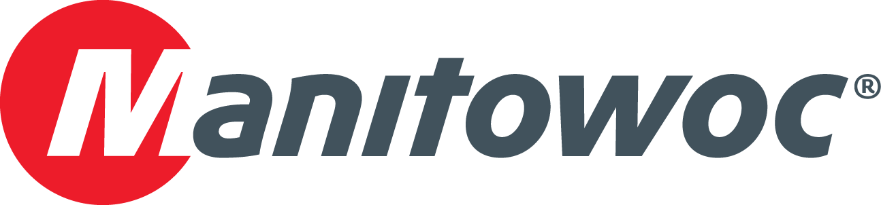

**Potain introduces Tower Crane Partner Development Program for Latin American dealers**

Manitowoc hosted a meeting for Latin America’s tower crane dealers in Panama in September to examine crane market opportunities and strategize over the best ways to address the region’s lifting challenges. Approximately 30 representatives from every Potain dealer in Latin America attended the event, what will now become an annual gathering.

“This meeting marked the rollout of the Tower Crane Partner Development Program in Latin America, a pioneering initiative in the industry and region designed to help the performance of distributors locally in several areas, including sales incentives, marketing support, and services enhancement,” said Mike Heacock, Manitowoc’s vice president of sales for Potain tower cranes in the Americas region.

The agenda for the day-long meeting included the introductions of Potain’s newly appointed tower crane staff; a review of latest products and innovations from Potain’s top slewing and self-erecting lines; and an overview of the Crane Care and Manitowoc Finance services offered in the region.

Participants also assessed the primary market trends shaping Latin America and shared their experiences working in the current economic climate. Several strategies were agreed upon to help fuel growth in the region. And for a bit of fun, the day ended with a tour of the Panama Canal.

-END-

CONTACT

**Leandro Moura** **Ricardo Rosa**

Manitowoc SE10

T +55 11 3103 0270 T +1 312 548 8444

[leandro.moura@manitowoc.com](mailto:amy.marten@manitowoc.com) ricardo.rosa@se10.com

ABOUT THE MANITOWOC COMPANY, INC.   
Founded in 1902, The Manitowoc Company, Inc. is a leading global manufacturer of cranes and lift solutions with manufacturing, distribution, and service facilities in 20 countries. Manitowoc is recognized as one of the premier innovators and providers of crawler cranes, tower cranes, and mobile cranes for the heavy construction industry, which are complemented by a slate of industry-leading aftermarket product support services. In 2015, Manitowoc’s revenues totaled $1.9 billion, with over half of these revenues generated outside the United States.

MANITOWOC CRANES

2401 South 30th Street - PO Box 70 - Manitowoc, WI 54221-0070

T +1 920 684 6621

[**www.manitowoc.com**](http://www.manitowoccranes.com)**­**