NEWS RELEASE

February 18, 2016

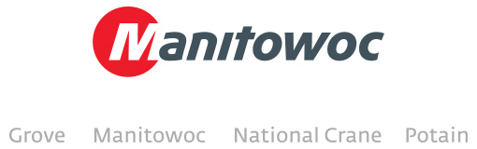

**Manitowoc announces new service center in Colombia**

Manitowoc Cranes has partnered with one of Colombia’s most established and well-known equipment specialists, Bogotá-based E McAllister, to offer after-sales support for its Manitowoc and Grove lines throughout the country.

“We are excited about this opportunity and look forward to developing this partnership to provide Manitowoc customers in Colombia with our time-tested experience in quality and reliable services,” said José Matiz, general manager at E McAllister.

For Manitowoc, the E McAllister service center in Colombia is another step towards its growing network of support services for customers and dealers in Latin America such as repairs, maintenance and other support.

“Manitowoc and Grove customers in Colombia can now count on the superior technical services Colombians have come to rely on at E McAllister,” said Fernando Camacho, Manitowoc’s regional business manager for Colombia and Ecuador. “E McAllister will offer preventive maintenance, repairs, and technical support for large operations.”

In addition to its Bogotá facilities, E McAllister operates a branch in the port city of Barranquilla and has plans to open two more locations, one in the southern part of the country and one in the flatlands. Founded in 1918 by Ernesto McAllister, the business is today run by the third generation of the McAllister family.

-END-

CONTACT

**Amy Marten** **Ricardo Rosa**

Manitowoc SE10

T +1 920 683 6345 T +1 312 548 8444

[amy.marten@manitowoc.com](mailto:chris.bratthauar@manitowoc.com) ricardo.rosa@se10.com

ABOUT THE MANITOWOC COMPANY, INC.   
Founded in 1902, The Manitowoc Company, Inc. is a multi-industry, capital goods manufacturer with 80 manufacturing, distribution, and service facilities in 25 countries. The company is recognized globally as one of the premier innovators and providers of crawler cranes, tower cranes, and mobile cranes for the heavy construction industry. Manitowoc is also one of the world's leading innovators and manufacturers of commercial foodservice equipment, which includes 23 market-leading brands of hot- and cold-focused equipment. In addition, both segments are complemented by a slate of industry-leading product support services. In 2015, Manitowoc’s revenues totaled $3.4 billion, with approximately half of these revenues generated outside of the United States.

MANITOWOC CRANES

2401 South 30th Street - PO Box 70 - Manitowoc, WI 54221-0070

T +1 920 684 6621

[**www.manitowoccranes.com**](http://www.manitowoccranes.com)**­**