­NEWS RELEASE

April 04, 2016

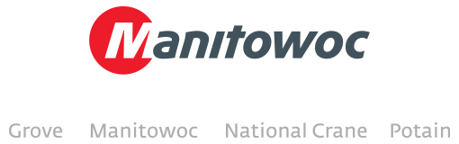

**Manitowoc appoints new Grove dealer in Hungary**

To develop and strengthen its presence in Hungary, Manitowoc Cranes recently appointed Axial Ltd as its Grove crane distributor in the country. Axial Ltd was founded in 1991 and operates from multiple locations across Hungary. The company will provide a number of services for Manitowoc customers including sales of new and used Grove cranes.

“We are extremely happy to welcome Axial Ltd as our new Grove dealer in Hungary,” says Thorsten Bolender, area sales manager at Manitowoc Cranes. “I am confident that we will have a strong partnership with Axial Ltd and we expect our presence in this market to grow as a result of this appointment. With locations in most of the major cities in Hungary, Axial Ltd will provide outstanding service to Manitowoc customers.”

Balint Kövecs, chief of the construction department at Axial Ltd, foresees an increase in Grove crane sales as Manitowoc expands its presence in the country. “We are excited to partner with a strong and dynamic company like Manitowoc,” he says. “Axial Ltd has a good reputation in Hungary and combined with Manitowoc’s industry-leading products and support services, we are predicting a period of growth for Grove cranes in the country.”

Other services that Axial Ltd will provide include rental and financial services for crane customers.

-END-

CONTACT

**Cristelle Lacourt** **Charlie Ebers**

Manitowoc SE10

T +1 920 683 6345 T +44 207 923 5864

[cristelle.lacourt@manitowoc.com](mailto:cristelle.lacourt@manitowoc.com) [charlie.ebers@se10.com](mailto:charlie.ebers@se10.com)

ABOUT THE MANITOWOC COMPANY, INC.   
Founded in 1902, The Manitowoc Company, Inc. is a leading global manufacturer of cranes and lift solutions with 49 manufacturing, distribution, and service facilities in 20 countries. Manitowoc is recognized as one of the premier innovators and providers of crawler cranes, tower cranes, and mobile cranes for the heavy construction industry, which are complemented by a slate of industry-leading aftermarket product support services. In 2015, Manitowoc’s revenues totaled $1.9 billion, with over half of these revenues generated outside the United States.

MANITOWOC CRANES

2401 South 30th Street - PO Box 70 - Manitowoc, WI 54221-0070

T +1 920 684 6621

[**www.manitowoccranes.com**](http://www.manitowoccranes.com)**­**