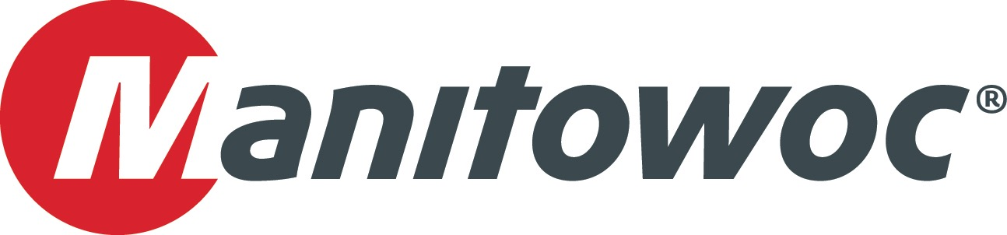NEWS RELEASE

October 7, 2016

**New company leaders for Asia and Middle East region**

As part of Manitowoc’s new sales organization the company has made two senior appointments for the Asia and Middle East region. Both David Semple and Christophe Simoncelli, who have assumed the new roles, have close to 20 years of experience at Manitowoc, working primarily in sales and general management functions across the company’s product lines.

The new roles have been created in alignment with Manitowoc’s recent reorganization, which saw its tower crane activities operated independently from its mobile crane and crawler crane operations. From a regional perspective, the company’s sales and marketing activities for Asia were also combined with those of the Middle East.

As a result, Christophe Simoncelli takes on the new role of vice president, tower crane sales, Asia and the Middle East. He was previously vice president of sales for Western Europe and French-speaking Africa. Simoncelli has relocated from France to Singapore, and has also assumed the role of general manager for the company’s regional headquarters in the country.

David Semple’s new title is senior vice president, mobile cranes, Asia and the Middle East. He was previously vice president of sales for the Middle East and English-speaking Africa; and will remain based in Dubai.

The respective tower crane and mobile crane organizations will cover a range of customer-facing activities, including: sales of new and used cranes; spare parts sales; rental sales; field service activities; marketing support; and marketing communications. Manitowoc’s reorganization of its operations will help the company bring more focus, greater innovation and increased velocity to its activities, all with the goal of delivering stronger value to customers.

Following the reorganization, Jack Lee, long-standing general manager of Crane Care in Asia, has announced his retirement. Raman Joshi, former executive vice president for Asia-Pacific, has also left the company.

-END-

CONTACT

**Punitha Govindasamy** **Ben Shaw**

Manitowoc SE10

T +65 6263 7863 T +65 6408 3861

[punitha.govindasamy@manitowoc.com](mailto:punitha.govindasamy@manitowoc.com) [ben.shaw@se10.com](mailto:ben.shaw@se10.com)

ABOUT THE MANITOWOC COMPANY, INC.

Founded in 1902, The Manitowoc Company, Inc. is a leading global manufacturer of cranes and lift solutions with manufacturing, distribution, and service facilities in 20 countries.  Manitowoc is recognized as one of the premier innovators and providers of crawler cranes, tower cranes, and mobile cranes for the heavy construction industry, which are complemented by a slate of industry-leading aftermarket product support services. In 2015, Manitowoc’s revenues totaled $1.9 billion, with over half of these revenues generated outside the United States.

MANITOWOC CRANES

2401 South 30th Street - PO Box 70 - Manitowoc, WI 54221-0070

T +1 920 684 6621

[www.manitowoc.com](http://www.manitowoc.com/)