­­­­NEWS RELEASE

October 23, 2015

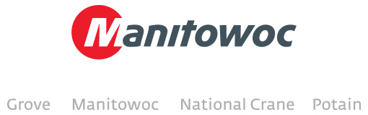

**Latest digital issue of *Looking UP* now available**

Inside you’ll find a wide array of stories from around the world that showcase the range of Manitowoc brands: Manitowoc, Grove, Potain and National Crane.

In this issue we feature:

* The Manitowoc 31000 on a staggering lift in South Korea
* A barge-mounted Manitowoc 888 Ringer that dazzled social media
* A new Product Verification Center in Germany that will scrutinize each and every component used to assemble cranes in the country
* New Potain MDT CCS City tower cranes
* A new Manitowoc Finance venture in Romania
* The “Designing for Experience” mantra that helped drive the creation of the innovative KZ-100 synthetic rope

These are among the many reports from companies and job sites around the globe. The lifting world moves fast, but Manitowoc is determined to stay at the top of it.

The digital issues of *Looking UP* are available in multiple languages:

* English
* French
* Spanish
* German
* Portuguese
* Chinese
* Italian

-END-

CONTACT

**Chris Bratthauar** **Damian Joseph**

Manitowoc SE10

T +1 717 593 5348 T +1 312 548 8441

[chris.bratthauar@manitowoc.com](mailto:chris.bratthauar@manitowoc.com) [damian.joseph@manitowoc.com](mailto:chris.bratthauar@manitowoc.com)

ABOUT THE MANITOWOC COMPANY, INC.

Founded in 1902, The Manitowoc Company, Inc. is a multi-industry, capital goods manufacturer with 92 manufacturing, distribution, and service facilities in 25 countries. The company is recognized globally as one of the premier innovators and providers of crawler cranes, tower cranes, and mobile cranes for the heavy construction industry. Manitowoc is also one of the world's leading innovators and manufacturers of commercial foodservice equipment, which includes 24 market-leading brands of hot- and cold-focused equipment. In addition, both segments are complemented by a slate of industry-leading product support services. In 2014, Manitowoc’s revenues totaled $3.9 billion, with approximately half of these revenues generated outside of the United States.

MANITOWOC CRANES

2401 South 30th Street - PO Box 70 - Manitowoc, WI 54221-0070

T +1 920 684 6621

[**www.manitowoccranes.com**](http://www.manitowoccranes.com)**­**