­­­­NEWS RELEASE

August 3, 2015

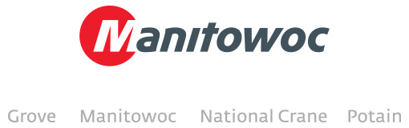

**Latest digital issue of *Looking UP* now available**

Inside you’ll find a wide array of stories from around the world that showcase the range of Manitowoc brands: Manitowoc, Grove, Potain and National Crane.

In this issue we feature:

* The new Grove GMK5250L all-terrain crane
* The Potain MR 418 and how its quick line speed and electric power are changing lifting work in New York City
* Specialized Crane Care service training for Latin America
* An EnCORE project that brought new life to a Manitowoc 4600 dragline
* The New NY Bridge infrastructure project and its fleet of Manitowoc-made cranes
* Six Potain tower cranes helping to build Israel’s tallest bridge
* A progress report on the testing of Manitowoc MLC650 VPC-MAX system

These are among the many reports from companies and job sites around the globe. The lifting world moves fast, but Manitowoc is determined to stay at the top of it.

The digital issues of *Looking UP* are available in multiple languages:

* English
* French
* Spanish
* German
* Portuguese
* Chinese
* Russian

-END-

CONTACT

**Chris Bratthauar** **Damian Joseph**

Manitowoc SE10

T +1 717 593 5348 T +1 312 548 8441

[chris.bratthauar@manitowoc.com](mailto:chris.bratthauar@manitowoc.com) [damian.joseph@manitowoc.com](mailto:chris.bratthauar@manitowoc.com)

ABOUT THE MANITOWOC COMPANY, INC.

Founded in 1902, The Manitowoc Company, Inc. is a multi-industry, capital goods manufacturer with 92 manufacturing, distribution, and service facilities in 25 countries. The company is recognized globally as one of the premier innovators and providers of crawler cranes, tower cranes, and mobile cranes for the heavy construction industry. Manitowoc is also one of the world's leading innovators and manufacturers of commercial foodservice equipment, which includes 24 market-leading brands of hot- and cold-focused equipment. In addition, both segments are complemented by a slate of industry-leading product support services. In 2014, Manitowoc’s revenues totaled $3.9 billion, with approximately half of these revenues generated outside of the United States.

MANITOWOC CRANES

2401 South 30th Street - PO Box 70 - Manitowoc, WI 54221-0070

T +1 920 684 6621

[**www.manitowoccranes.com**](http://www.manitowoccranes.com)**­**