SALES ANNOUNCEMENT
June 19, 2015
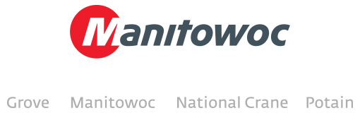

UK’s Quinto Crane and Plant Hire revamps crane fleet with new Grove GMK4100L

Under new ownership following its recent acquisition, Norwich-based Quinto Crane and Plant Hire, has already initiated its crane fleet replacement programme. Following the purchase of a Grove GMK6300L last year, the crane hire company’s latest addition to the fleet is a 100 t capacity Grove GMK4100L.

The four-axle crane was presented by Manitowoc at this year’s Vertikal Days trade show, where the purchase was signed and sealed.

Owner of Quinto Crane and Plant Hire, Oliver Arnold, was pleased to see the crane presented at the show: “We’ve been impressed with the performance of the new Grove GMK6300L and we’re confident in our latest purchase of the GMK4100L,” he said. “Its long boom and highly versatile capabilities make it ideal for congested job sites in the UK.”

The GMK4100L is the long-boom version of the popular GMK4100 four-axle all-terrain crane. Featuring an impressive 60 m boom, the Grove crane can lift an impressive 1.6 t at a 48 m radius. At just 10.7 m long, the crane’s carrier, which includes all-wheel steering and Megatrak suspension, is compact and highly maneuverable.

-END-

CONTACT CONTACT
Cristelle Lacourt Yasmine Triana
Manitowoc SE10
T +33 472 182 018 T +44 207 923 5867
cristelle.lacourt@manitowoc.com yasmine.triana@se10.com

ABOUT THE MANITOWOC COMPANY, INC.
Founded in 1902, The Manitowoc Company, Inc. is a multi-industry, capital goods manufacturer with 92 manufacturing, distribution, and service facilities in 25 countries. The company is recognized globally as one of the premier innovators and providers of crawler cranes, tower cranes, and mobile cranes for the heavy construction industry. Manitowoc is also one of the world's leading innovators and manufacturers of commercial foodservice equipment, which includes 24 market-leading brands of hot- and cold-focused equipment. In addition, both segments are complemented by a slate of industry-leading product support services. In 2014, Manitowoc’s revenues totaled $3.9 billion, with approximately half of these revenues generated outside of the United States.

MANITOWOC CRANES
2401 South 30th Street - PO Box 70 - Manitowoc, WI 54221-0070
T +1 920 684 6621
www.manitowoccranes.com

