SALES ANNOUNCEMENT

July 13, 2015

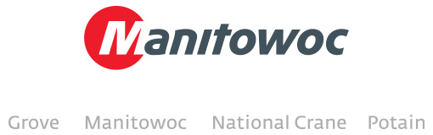

**New GMK4100L added to Hird Group crane fleet**

Hird Group, a leading UK access platform and lifting specialist, has added another Grove crane to its fleet. The company has recently purchased a 100 t capacity Grove GMK4100L all-terrain crane, which will be delivered and installed at its headquarters in Hull at the end of August.

The four-axle crane was presented by Manitowoc at this year’s Vertikal Days trade show, where the purchase was finalized.

“We’ve been impressed with other existing Grove cranes in our fleet and we are happy with our most recent purchase of the GMK4100L,” said Philip Hird, managing director for Hird. “Its long boom and highly versatile capabilities make it ideal for congested job sites in the UK and the crane will be used at many sites around the country.”

The GMK4100L is the long-boom version of the popular GMK4100 four-axle all-terrain crane. Featuring a 60 m boom, the Grove crane can lift an impressive 1.6 t at a 48 m radius. At just 10.7 m long, the crane’s carrier, which includes all-wheel steering and Megatrak suspension, is compact and highly maneuverable.

-END-

CONTACT CONTACT

**Cristelle Lacourt** **Yasmine Triana**

Manitowoc SE10

T +33 472 182 018 T +44 207 923 5867

[cristelle.lacourt@manitowoc.com](mailto:cristelle.lacourt@manitowoc.com%20)  [yasmine.triana@se10.com](mailto:yasmine.triana@se10.com)

ABOUT THE MANITOWOC COMPANY, INC.   
Founded in 1902, The Manitowoc Company, Inc. is a multi-industry, capital goods manufacturer with 92 manufacturing, distribution, and service facilities in 25 countries. The company is recognized globally as one of the premier innovators and providers of crawler cranes, tower cranes, and mobile cranes for the heavy construction industry. Manitowoc is also one of the world's leading innovators and manufacturers of commercial foodservice equipment, which includes 24 market-leading brands of hot- and cold-focused equipment. In addition, both segments are complemented by a slate of industry-leading product support services. In 2014, Manitowoc’s revenues totaled $3.9 billion, with approximately half of these revenues generated outside of the United States.

MANITOWOC CRANES

2401 South 30th Street - PO Box 70 - Manitowoc, WI 54221-0070

T +1 920 684 6621

[**www.manitowoccranes.com**](http://www.manitowoccranes.com)**­**