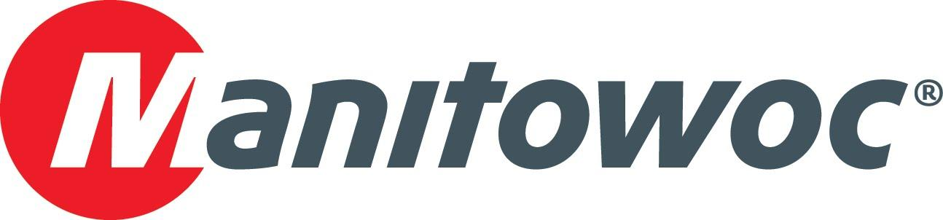
Caption Release

Road Machinery & Supplies Co. celebrates 50 years as Grove dealer at CONEXPO 2020

To mark five successful decades as a Grove dealer in Northern Minnesota, Road Machinery & Supplies Co. (RMS) joined Manitowoc staff at the manufacturer’s booth at CONEXPO 2020. RMS’s Jon Anderson (center), along with Manitowoc’s Mike Heacock and Keith Crider, stand in front of a Grove GRT9165, one of the 10 cranes the manufacturer exhibited at the show this year.

Based in Savage, Minnesota, RMS represents Grove and provides customer support in north central and northeast Minnesota.

-END-

CONTACT
Amy Marten
Manitowoc
T +1 920 683 6345
amy.marten@manitowoc.com

ABOUT THE MANITOWOC COMPANY, INC.
The Manitowoc Company, Inc. (“Manitowoc”) was founded in 1902 and has over a 117-year tradition of providing high-quality, customer-focused products and support services to its markets and its 2019 net sales were approximately $1.83 billion. Manitowoc is one of the world's leading providers of engineered lifting solutions. Manitowoc, through its wholly-owned subsidiaries, designs, manufactures, markets, and supports comprehensive product lines of mobile telescopic cranes, tower cranes, lattice-boom crawler cranes, and boom trucks under the Grove, Manitowoc, National Crane, Potain, Shuttlelift and Manitowoc Crane Care brand names.

THE MANITOWOC COMPANY, INC.
One Park Plaza – 11270 West Park Place – Suite 1000 – Milwaukee, WI 53224, USA
T +1 414 760 4600
www.manitowoc.com

