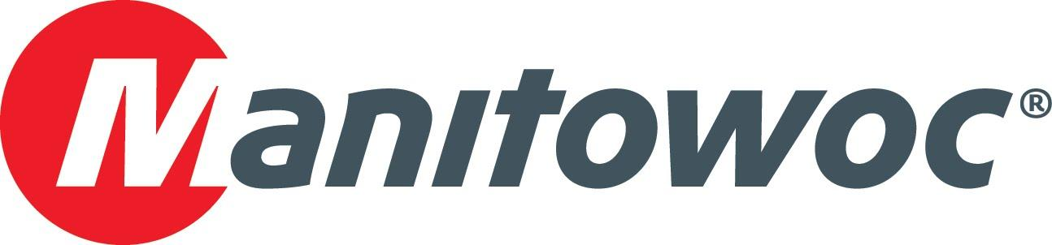
Caption Release

Davis Crane Service celebrates its 10 new Grove TMS500-2 truck cranes at CONEXPO 2020

Offering one of the most modern crane fleets in Texas, Davis Crane Service is always on the lookout for new technologies that can make work on job sites more efficient. At this year’s CONEXPO, the company’s team visited Manitowoc’s booth and was recognized for boldly expanding its fleet with 10 Grove TMS500-2 truck cranes in 2019.

To celebrate the acquisition of these versatile cranes, Manitowoc’s Dave Hull, Aaron Ravenscroft and Les Middleton offered a celebratory plaque to Davis Crane Service staff at the show, including Dennis Davis, Keith McKee and Wes Dowd. Based in Irving, Texas, Davis Crane Service serves the state with six locations.

-END-

CONTACT
Amy Marten
Manitowoc
T +1 920 683 6345
amy.marten@manitowoc.com

ABOUT THE MANITOWOC COMPANY, INC.
The Manitowoc Company, Inc. (“Manitowoc”) was founded in 1902 and has over a 117-year tradition of providing high-quality, customer-focused products and support services to its markets and its 2019 net sales were approximately $1.83 billion. Manitowoc is one of the world's leading providers of engineered lifting solutions. Manitowoc, through its wholly-owned subsidiaries, designs, manufactures, markets, and supports comprehensive product lines of mobile telescopic cranes, tower cranes, lattice-boom crawler cranes, and boom trucks under the Grove, Manitowoc, National Crane, Potain, Shuttlelift and Manitowoc Crane Care brand names.

THE MANITOWOC COMPANY, INC.
One Park Plaza – 11270 West Park Place – Suite 1000 – Milwaukee, WI 53224, USA
T +1 414 760 4600
www.manitowoc.com

