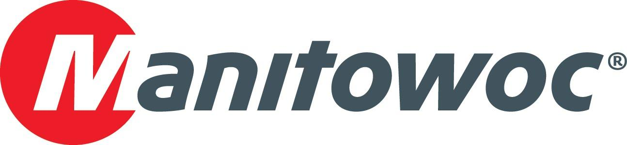
Caption Release

Circle 8 Crane Services celebrates its 100th Manitowoc crane at CONEXPO 2020

Eleven years after purchasing its first Manitowoc crane, Circle 8 Crane Services celebrated the 100th addition to its fleet: a Grove GMK5200-1, which is expected to be delivered in the coming weeks. Based in Houston, Texas, the company provides mobile cranes and services to customers from several other locations in Texas, Oklahoma, Louisiana and New Mexico.

Manitowoc’s Dave Hull, Les Middleton and Mike Herbert presented Circle 8 Crane Services’ team — Damon Green, Phillip Bryson, Douglas Dangler, Allen Bryson and Brett Rhuland — with a celebratory plaque to commemorate its 100th crane and the thriving partnership between both companies.

-END-

CONTACT
Amy Marten
Manitowoc
T +1 920 683 6345
amy.marten@manitowoc.com

ABOUT THE MANITOWOC COMPANY, INC.
The Manitowoc Company, Inc. (“Manitowoc”) was founded in 1902 and has over a 117-year tradition of providing high-quality, customer-focused products and support services to its markets and its 2019 net sales were approximately $1.83 billion. Manitowoc is one of the world's leading providers of engineered lifting solutions. Manitowoc, through its wholly-owned subsidiaries, designs, manufactures, markets, and supports comprehensive product lines of mobile telescopic cranes, tower cranes, lattice-boom crawler cranes, and boom trucks under the Grove, Manitowoc, National Crane, Potain, Shuttlelift and Manitowoc Crane Care brand names.

THE MANITOWOC COMPANY, INC.
One Park Plaza – 11270 West Park Place – Suite 1000 – Milwaukee, WI 53224, USA
T +1 414 760 4600
www.manitowoc.com

