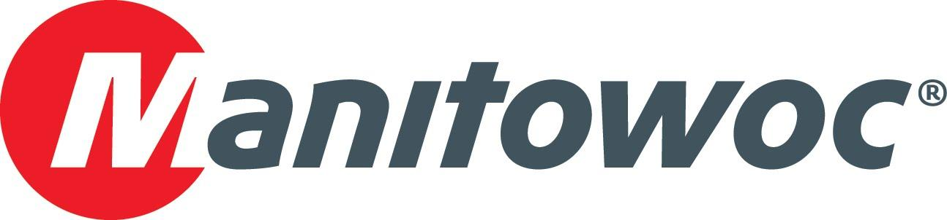
Caption Release

NessCampbell Crane + Rigging purchases an MLC300 crawler crane at CONEXPO 2020

At CONEXPO 2020, Manitowoc celebrated a new purchase with NessCampbell Crane + Rigging: a Manitowoc MLC300 crawler crane. Manitowoc’s Les Middleton, David Hull, Harrison Hipple and Kevin Blaney presented NessCampbell’s team, including Jonelle Anderson and John Anderson, a celebratory plaque to mark the occasion. Joining the celebration at the Manitowoc’s booth at the show were boxing legend Larry Holmes, Manitowoc’s dealer Western Pacific Crane & Equipment and members of the Lanco Group.

“The MLC300 is an innovative crane and will be a powerful addition to our rental fleet,” John Anderson said.

-END-

CONTACT
Amy Marten
Manitowoc
T +1 920 683 6345
amy.marten@manitowoc.com

ABOUT THE MANITOWOC COMPANY, INC.
The Manitowoc Company, Inc. (“Manitowoc”) was founded in 1902 and has over a 117-year tradition of providing high-quality, customer-focused products and support services to its markets and its 2019 net sales were approximately $1.83 billion. Manitowoc is one of the world's leading providers of engineered lifting solutions. Manitowoc, through its wholly-owned subsidiaries, designs, manufactures, markets, and supports comprehensive product lines of mobile telescopic cranes, tower cranes, lattice-boom crawler cranes, and boom trucks under the Grove, Manitowoc, National Crane, Potain, Shuttlelift and Manitowoc Crane Care brand names.

THE MANITOWOC COMPANY, INC.
One Park Plaza – 11270 West Park Place – Suite 1000 – Milwaukee, WI 53224, USA
T +1 414 760 4600
www.manitowoc.com

