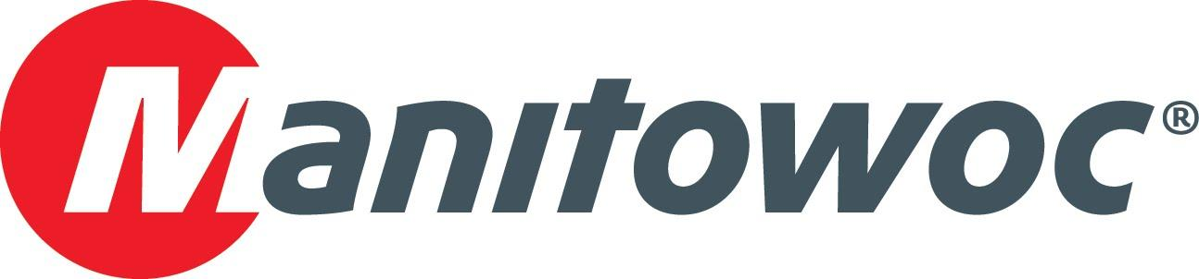
Caption Release

Maniobras Especializadas celebrates the purchase of a Grove TMS500-2 at CONEXPO 2020

Hailing from Villahermosa, Mexico, Maniobras Especializadas’ team met with Manitowoc’s representatives at CONEXPO 2020 and celebrated the company’s latest acquisition: a Grove TMS500-2 truck mounted crane. The 36 t (40 USt) capacity crane was on display at Manitowoc’s booth at the show this year.

Staff from both companies include Oscar Garza Senior, Oscar Garza, Sergio Garza, Israel Lopez and Miguel Lopez from Maniobras Especializadas, and Dave Hull, Jose Maya, Guillermo Vasquez and Les Middleton from Manitowoc.

-END-

CONTACT
Amy Marten
Manitowoc
T +1 920 683 6345
amy.marten@manitowoc.com

ABOUT THE MANITOWOC COMPANY, INC.
The Manitowoc Company, Inc. (“Manitowoc”) was founded in 1902 and has over a 117-year tradition of providing high-quality, customer-focused products and support services to its markets and its 2019 net sales were approximately $1.83 billion. Manitowoc is one of the world's leading providers of engineered lifting solutions. Manitowoc, through its wholly-owned subsidiaries, designs, manufactures, markets, and supports comprehensive product lines of mobile telescopic cranes, tower cranes, lattice-boom crawler cranes, and boom trucks under the Grove, Manitowoc, National Crane, Potain, Shuttlelift and Manitowoc Crane Care brand names.

THE MANITOWOC COMPANY, INC.
One Park Plaza – 11270 West Park Place – Suite 1000 – Milwaukee, WI 53224, USA
T +1 414 760 4600
www.manitowoc.com

