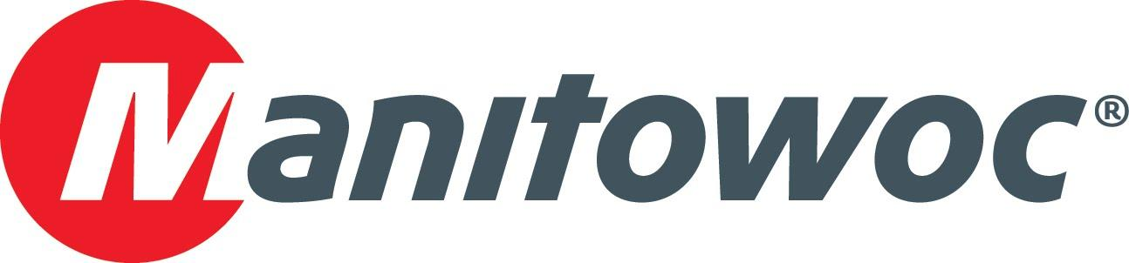
Caption Release

Stirnimann celebrates 50-year partnership with Grove at CONEXPO 2020

A leader in the construction and transportation industries across Europe, Stirnimann commemorated five decades of a successful relationship with Grove at the Manitowoc Cranes booth during CONEXPO 2020. Several representatives from Olten, Switzerland-based Stirnimann visited with Manitowoc’s team, which included Orlando Mota, Aaron Ravenscroft and Erdogan Arslan.

-END-

CONTACT
Amy Marten
Manitowoc
T +1 920 683 6345
amy.marten@manitowoc.com

ABOUT THE MANITOWOC COMPANY, INC.
The Manitowoc Company, Inc. (“Manitowoc”) was founded in 1902 and has over a 117-year tradition of providing high-quality, customer-focused products and support services to its markets and its 2019 net sales were approximately $1.83 billion. Manitowoc is one of the world's leading providers of engineered lifting solutions. Manitowoc, through its wholly-owned subsidiaries, designs, manufactures, markets, and supports comprehensive product lines of mobile telescopic cranes, tower cranes, lattice-boom crawler cranes, and boom trucks under the Grove, Manitowoc, National Crane, Potain, Shuttlelift and Manitowoc Crane Care brand names.

THE MANITOWOC COMPANY, INC.
One Park Plaza – 11270 West Park Place – Suite 1000 – Milwaukee, WI 53224, USA
T +1 414 760 4600
www.manitowoc.com

