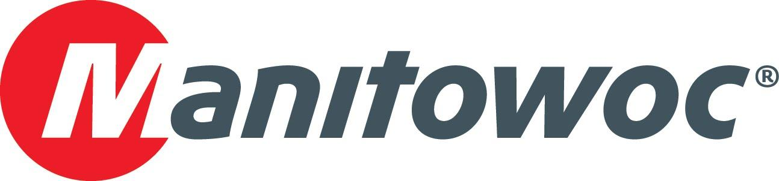
Caption Release

SCU Crane and Rigging purchased the Grove GHC140 on display at CONEXPO

SCU Crane and Rigging (SCU) celebrated the purchase of a new Grove GHC140 telescopic crawler crane at CONEXPO 2020. The crane, which is the highest-capacity model in the Grove telescopic crawler range, was launched in 2019 and features best-in-class load charts for its capacity range. The company commemorated the new addition to its fleet with Grove dealer Hayden-Murphy at Manitowoc’s booth in Las Vegas, where the exact crane it purchased was on display. Manitowoc’s Colby Bingaman hosted teams from both SCU and Hayden-Murphy and toasted the purchase with Traci and Tim Mohr, from SCU, and Jeremy Torgerson, Ken Boehm and Randy Schmoll, from Hayden-Murphy.

-END-

CONTACT
Amy Marten
Manitowoc
T +1 920 683 6345
amy.marten@manitowoc.com

ABOUT THE MANITOWOC COMPANY, INC.
The Manitowoc Company, Inc. (“Manitowoc”) was founded in 1902 and has over a 117-year tradition of providing high-quality, customer-focused products and support services to its markets and its 2019 net sales were approximately $1.83 billion. Manitowoc is one of the world's leading providers of engineered lifting solutions. Manitowoc, through its wholly-owned subsidiaries, designs, manufactures, markets, and supports comprehensive product lines of mobile telescopic cranes, tower cranes, lattice-boom crawler cranes, and boom trucks under the Grove, Manitowoc, National Crane, Potain, Shuttlelift and Manitowoc Crane Care brand names.

THE MANITOWOC COMPANY, INC.
One Park Plaza – 11270 West Park Place – Suite 1000 – Milwaukee, WI 53224, USA
T +1 414 760 4600
www.manitowoc.com

