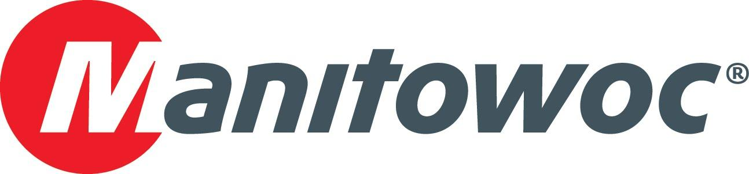
Caption Release

Imperial Crane Services celebrated its 50th anniversary with Manitowoc at CONEXPO

Imperial Crane Services commemorated 50 years in business at the Manitowoc booth during CONEXPO 2020. The Bridgeview, Illinois-based company’s leadership, including Larry Eckardt, Jeff and Taurrie Bohne, commemorated the golden anniversary with Manitowoc’s Harrison Hipple and Dave Hull. Manitowoc dealer Walter Payton Power Equipment, which has been a long time supporter of Imperial Crane Services, was also on hand for the occasion, with Phil Wichowsky, Tacho Gamino, Brian Lynch, Dave Wisnieski and Brian Brander all taking part in the celebration.

-END-

CONTACT
Amy Marten
Manitowoc
T +1 920 683 6345
amy.marten@manitowoc.com

ABOUT THE MANITOWOC COMPANY, INC.
The Manitowoc Company, Inc. (“Manitowoc”) was founded in 1902 and has over a 117-year tradition of providing high-quality, customer-focused products and support services to its markets and its 2019 net sales were approximately $1.83 billion. Manitowoc is one of the world's leading providers of engineered lifting solutions. Manitowoc, through its wholly-owned subsidiaries, designs, manufactures, markets, and supports comprehensive product lines of mobile telescopic cranes, tower cranes, lattice-boom crawler cranes, and boom trucks under the Grove, Manitowoc, National Crane, Potain, Shuttlelift and Manitowoc Crane Care brand names.

THE MANITOWOC COMPANY, INC.
One Park Plaza – 11270 West Park Place – Suite 1000 – Milwaukee, WI 53224, USA
T +1 414 760 4600
www.manitowoc.com

