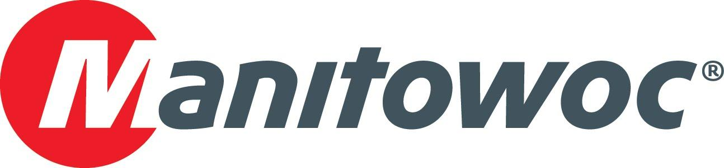
Caption Release

APR Grúas y Logística celebrated its successful partnership with Grove at CONEXPO 2020

Mexico’s APR Grúas y Logística visited the Manitowoc Cranes booth at CONEXPO 2020 to celebrate its fruitful partnership with Grove. Manitowoc’s Jose Maya and Guillermo Vazquez presented Luis Alfonso Perez Frias and Miguel Perez Frias a celebratory plaque to commemorate the company’s dedication to selling and supporting Grove rough-terrain and all-terrain cranes.

-END-

CONTACT
Amy Marten
Manitowoc
T +1 920 683 6345
amy.marten@manitowoc.com

ABOUT THE MANITOWOC COMPANY, INC.
The Manitowoc Company, Inc. (“Manitowoc”) was founded in 1902 and has over a 117-year tradition of providing high-quality, customer-focused products and support services to its markets and its 2019 net sales were approximately $1.83 billion. Manitowoc is one of the world's leading providers of engineered lifting solutions. Manitowoc, through its wholly-owned subsidiaries, designs, manufactures, markets, and supports comprehensive product lines of mobile telescopic cranes, tower cranes, lattice-boom crawler cranes, and boom trucks under the Grove, Manitowoc, National Crane, Potain, Shuttlelift and Manitowoc Crane Care brand names.

THE MANITOWOC COMPANY, INC.
One Park Plaza – 11270 West Park Place – Suite 1000 – Milwaukee, WI 53224, USA
T +1 414 760 4600
www.manitowoc.com

