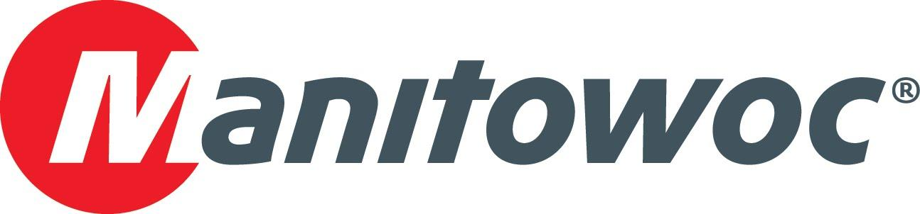
Caption Release

Vanwyck Crane Service celebrates Manitowoc partnership at CONEXPO 2020

Vanwyck Crane Service celebrated its partnership with Manitowoc Cranes during the first day of CONEXPO 2020. Colby Bingaman, Mike Reed and JJ Grace, all of Manitowoc Cranes, hosted Doug Vanwyck (second from left) at the Manitowoc booth, presenting him with a celebratory plaque to commemorate his company’s dedication to using Manitowoc cranes.

-END-

CONTACT
Amy Marten
Manitowoc
T +1 920 683 6345
amy.marten@manitowoc.com

ABOUT THE MANITOWOC COMPANY, INC.
The Manitowoc Company, Inc. (“Manitowoc”) was founded in 1902 and has over a 117-year tradition of providing high-quality, customer-focused products and support services to its markets and its 2019 net sales were approximately $1.83 billion. Manitowoc is one of the world's leading providers of engineered lifting solutions. Manitowoc, through its wholly-owned subsidiaries, designs, manufactures, markets, and supports comprehensive product lines of mobile telescopic cranes, tower cranes, lattice-boom crawler cranes, and boom trucks under the Grove, Manitowoc, National Crane, Potain, Shuttlelift and Manitowoc Crane Care brand names.

THE MANITOWOC COMPANY, INC.
One Park Plaza – 11270 West Park Place – Suite 1000 – Milwaukee, WI 53224, USA
T +1 414 760 4600
www.manitowoc.com

