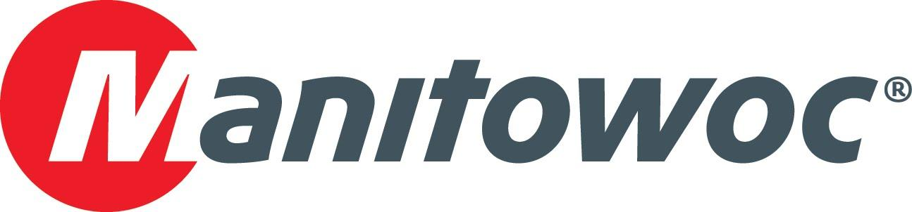
Caption Release

Manitowoc awards Ring Power Crane for Grove growth and EnCORE prowess

Ring Power Crane and Manitowoc had a lot to celebrate at this year’s CONEXPO. Manitowoc gave the St. Augustine, Florida-based company an award for having the highest volume growth of Grove cranes in North America. It also recognized the company for being the exclusive EnCORE service provider in its territory.

Ring Power Corporation President David Alban, Executive Vice President Kevin Robbins and Vice President/General Manager of Ring Power Crane Dave Glass received the award at the Manitowoc booth. Manitowoc’s Keith Crider and Mike Herbert presented them with celebratory plaques to mark the occasion, kicking off what has already been a fruitful CONEXPO for Manitowoc.

-END-

CONTACT
Amy Marten
Manitowoc
T +1 920 683 6345
amy.marten@manitowoc.com

ABOUT THE MANITOWOC COMPANY, INC.
The Manitowoc Company, Inc. (“Manitowoc”) was founded in 1902 and has over a 117-year tradition of providing high-quality, customer-focused products and support services to its markets and its 2019 net sales were approximately $1.83 billion. Manitowoc is one of the world's leading providers of engineered lifting solutions. Manitowoc, through its wholly-owned subsidiaries, designs, manufactures, markets, and supports comprehensive product lines of mobile telescopic cranes, tower cranes, lattice-boom crawler cranes, and boom trucks under the Grove, Manitowoc, National Crane, Potain, Shuttlelift and Manitowoc Crane Care brand names.

THE MANITOWOC COMPANY, INC.
One Park Plaza – 11270 West Park Place – Suite 1000 – Milwaukee, WI 53224, USA
T +1 414 760 4600
www.manitowoc.com

