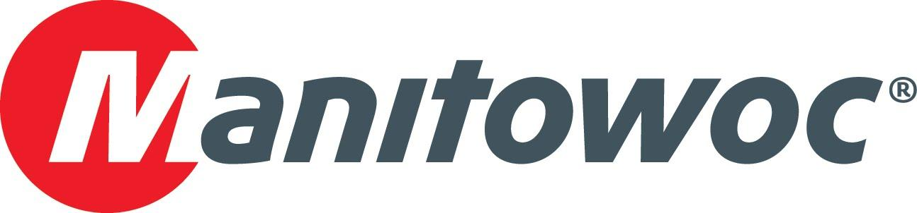
Caption Release

RMS Rentals commemorates its Potain partnership at CONEXPO 2020

RMS Rentals visited the Manitowoc CONEXPO booth in Las Vegas to celebrate the Minneapolis, Minnesota-based company’s fruitful partnership with Potain tower cranes. Gael Veillard and David Polce, both of Manitowoc Cranes, presented a celebratory plaque to RMS Rentals’ Vice President Sales and Marketing Andy Schwandt and General Manager Steven Klatt to mark the occasion.

“Why Potain? They are efficient mobile cranes that are variably used in the marketplace,” Schwandt said. “We’ve had a great relationship with Manitowoc for 16-plus years.”

-END-

CONTACT
Amy Marten
Manitowoc
T +1 920 683 6345
amy.marten@manitowoc.com

ABOUT THE MANITOWOC COMPANY, INC.
The Manitowoc Company, Inc. (“Manitowoc”) was founded in 1902 and has over a 117-year tradition of providing high-quality, customer-focused products and support services to its markets and its 2019 net sales were approximately $1.83 billion. Manitowoc is one of the world's leading providers of engineered lifting solutions. Manitowoc, through its wholly-owned subsidiaries, designs, manufactures, markets, and supports comprehensive product lines of mobile telescopic cranes, tower cranes, lattice-boom crawler cranes, and boom trucks under the Grove, Manitowoc, National Crane, Potain, Shuttlelift and Manitowoc Crane Care brand names.

THE MANITOWOC COMPANY, INC.
One Park Plaza – 11270 West Park Place – Suite 1000 – Milwaukee, WI 53224, USA
T +1 414 760 4600
www.manitowoc.com

