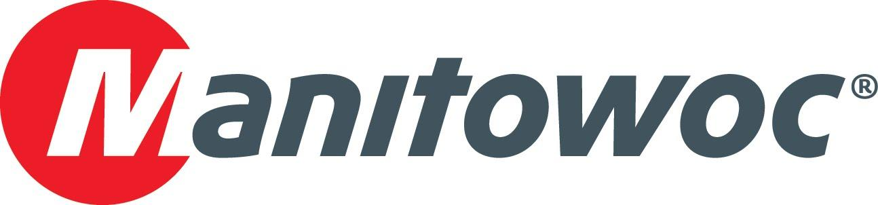
Caption Release

Maxim Crane Works celebrates Potain growth while purchasing the first North American Grove GMK5250XL-1 at CONEXPO 2020

Maxim Crane Works just picked up an award from Manitowoc Cranes for being the number one Potain tower crane customer by dollar amount and number one top slewing crane customer by units in North America over the last three years, CONEXPO 2017 — CONEXPO 2020. The Pennsylvania-based company has been an early adopter and dedicated renter of many models of Potain tower cranes over the years, significantly influencing the lifting industry across the country.

And continuing its commitment to Manitowoc, Maxim Crane Works also celebrated the purchase of the first Grove GMK5250XL-1 for North America. The crane was launched at bauma 2019 and makes its North American debut at CONEXPO 2020, where the company’s leadership, including the COO Frank Bardonaro, CEO Bryan Carlisle and CFO Carl Laurino commemorated its purchase in a ceremony with Manitowoc’s Mike Heacock, Les Middleton, John Kennedy and David Hull.

-END-

CONTACT
Amy Marten
Manitowoc
T +1 920 683 6345
amy.marten@manitowoc.com

ABOUT THE MANITOWOC COMPANY, INC.
The Manitowoc Company, Inc. (“Manitowoc”) was founded in 1902 and has over a 117-year tradition of providing high-quality, customer-focused products and support services to its markets and its 2019 net sales were approximately $1.83 billion. Manitowoc is one of the world's leading providers of engineered lifting solutions. Manitowoc, through its wholly-owned subsidiaries, designs, manufactures, markets, and supports comprehensive product lines of mobile telescopic cranes, tower cranes, lattice-boom crawler cranes, and boom trucks under the Grove, Manitowoc, National Crane, Potain, Shuttlelift and Manitowoc Crane Care brand names.

THE MANITOWOC COMPANY, INC.
One Park Plaza – 11270 West Park Place – Suite 1000 – Milwaukee, WI 53224, USA
T +1 414 760 4600
www.manitowoc.com

