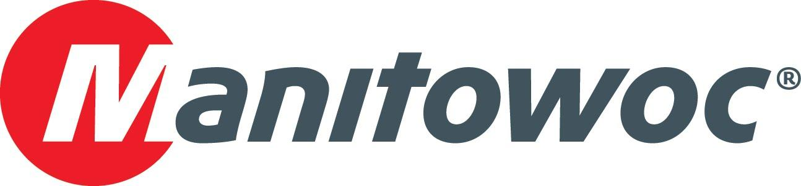
CAPTION RELEASE

CraneWorks commemorates CONEXPO with National Crane boom trucks

CraneWorks CEO Keith Ayers visited with Manitowoc Cranes at CONEXPO 2020 to celebrate his company’s renewed commitment to National Crane boom trucks. The Houston, Texas-based company is one of the fastest growing in the lifting industry, utilizing many National Crane models in a fleet that has offices in Kansas, Florida, Colorado, California, New Jersey and Canada. Manitowoc’s Mike Heinrich, Randy Hoover, David Hull and Justin Pilgrim presented Ayers (center) with a celebratory plaque to mark the occasion, and the group enjoyed a champagne toast together at the Manitowoc booth.

-END-

CONTACT
Amy Marten
Manitowoc
T +1 920 683 6345
amy.marten@manitowoc.com

ABOUT THE MANITOWOC COMPANY, INC.
The Manitowoc Company, Inc. (“Manitowoc”) was founded in 1902 and has over a 117-year tradition of providing high-quality, customer-focused products and support services to its markets and its 2019 net sales were approximately $1.83 billion. Manitowoc is one of the world's leading providers of engineered lifting solutions. Manitowoc, through its wholly-owned subsidiaries, designs, manufactures, markets, and supports comprehensive product lines of mobile telescopic cranes, tower cranes, lattice-boom crawler cranes, and boom trucks under the Grove, Manitowoc, National Crane, Potain, Shuttlelift and Manitowoc Crane Care brand names.

THE MANITOWOC COMPANY, INC.
One Park Plaza – 11270 West Park Place – Suite 1000 – Milwaukee, WI 53224, USA
T +1 414 760 4600
www.manitowoc.com

