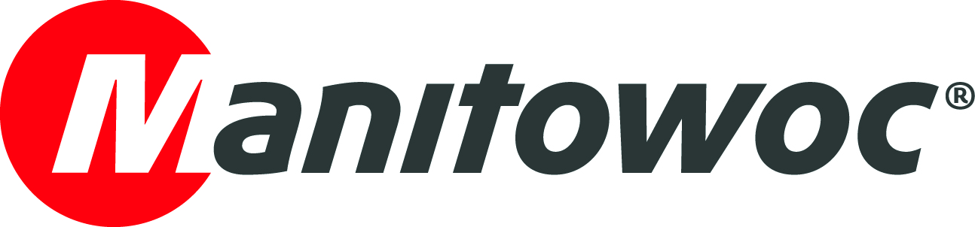
Caption Release

June 24, 2020

Sarens Canada strengthens its fleet with three new National Crane boom trucks supplied by Strongco
Sarens Canada just added three National Crane boom trucks to its fleet, further strengthening its repertoire of dependable, durable truck-mounted cranes that serve Canada and beyond.
“We’d like to thank Lee Rowe and his team at Sarens Canada for the recent acquisition of two new National Crane NBT30H-2s (30 USt capacity) and a new long-reach NBT55L (55 USt capacity),” said Chris Gray, territory manager at Strongco, which supplied the boom trucks to Sarens Canada at the handover ceremony in early June. “We look forward to supporting Sarens Canada as they continue to grow in the country and other regions.”
To learn more about the NBT30H-2, click here; to see more details of the NBT55L, click here.

Photo: Sarens Canada’s Operator John Burnie, Branch Manager Ontario Luke Goodfellow, supervisors Allan Whittington and Patrick McMonagle and Country Manager Lee Rowe.

-END-

CONTACT
Amy Marten
Manitowoc
T +1 920 683 6345
amy.marten@manitowoc.com

ABOUT THE MANITOWOC COMPANY, INC.
The Manitowoc Company, Inc. (“Manitowoc”) was founded in 1902 and has over a 117-year tradition of providing high-quality products and support services that are tailored to customers’ needs. Its 2019 net sales were approximately $1.83 billion. Manitowoc is one of the world's leading providers of engineered lifting solutions. Through its wholly-owned subsidiaries, Manitowoc designs, manufactures, markets and supports comprehensive product lines of mobile telescopic cranes, tower cranes, lattice-boom crawler cranes, boom trucks and industrial cranes under the Grove, Potain, Manitowoc, National Crane, Shuttlelift and Manitowoc Crane Care brand names.

THE MANITOWOC COMPANY, INC.
One Park Plaza – 11270 West Park Place – Suite 1000 – Milwaukee, WI 53224, USA
T +1 414 760 4600
www.manitowoc.com

