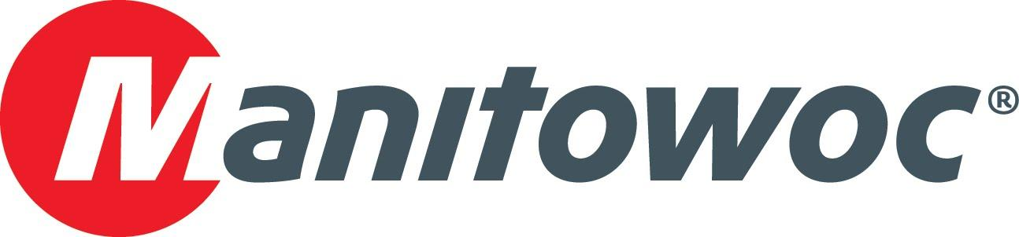
Caption Release

Hoffman Equipment celebrates its 100th anniversary with new cranes from Manitowoc and Grove

Hoffman Equipment marked one century in the lifting equipment industry at this year’s CONEXPO. The Piscataway, New Jersey-based family-run company celebrated the date expanding its fleet with new Manitowoc and Grove cranes purchased at the show. The new acquisitions include a Grove GRT8120 rough-terrain and a Manitowoc MLC150-1 crawler crane (both launched at CONEXPO), a Grove GRT880, an RT770 and a Manitowoc MLC100-1.

Manitowoc’s Dave Hull, Keith Crider and Les Middleton presented Hoffman Equipment President and CEO Tim Watters and team — Pat Tomasetti, Joe Teahl, Mike Anderson, Steve Izzi, Eric Seikel and Walt Joachim — a celebratory plaque to mark the occasion.

-END-

CONTACT
Amy Marten
Manitowoc
T +1 920 683 6345
amy.marten@manitowoc.com

ABOUT THE MANITOWOC COMPANY, INC.
The Manitowoc Company, Inc. (“Manitowoc”) was founded in 1902 and has over a 117-year tradition of providing high-quality, customer-focused products and support services to its markets and its 2019 net sales were approximately $1.83 billion. Manitowoc is one of the world's leading providers of engineered lifting solutions. Manitowoc, through its wholly-owned subsidiaries, designs, manufactures, markets, and supports comprehensive product lines of mobile telescopic cranes, tower cranes, lattice-boom crawler cranes, and boom trucks under the Grove, Manitowoc, National Crane, Potain, Shuttlelift and Manitowoc Crane Care brand names.

THE MANITOWOC COMPANY, INC.
One Park Plaza – 11270 West Park Place – Suite 1000 – Milwaukee, WI 53224, USA
T +1 414 760 4600
www.manitowoc.com

