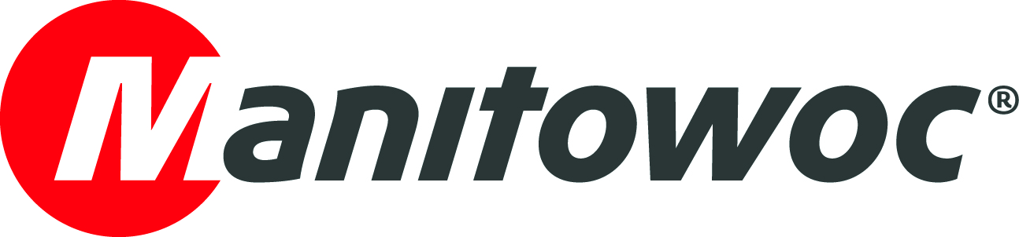
CAPTION RELEASE

April 25, 2019

Manitowoc pledges to help reconstruct Notre-Dame

Following the fire that caused large-scale damage to Notre-Dame de Paris, Potain – Manitowoc’s manufacturer of tower cranes – has pledged to support reconstruction efforts of the historic French cathedral.

Manitowoc will provide tower cranes and related services free of charge. The terms of this offer have now been officially presented to the authorities.

"It seemed natural to us that Potain, our tower crane brand that for more than 90 years has been involved in the construction of the most emblematic works of French architecture, is committed to rebuilding Notre Dame de Paris. Our cranes and technical expertise will be there to meet the challenge of a rapid reconstruction of the cathedral,” said Barry Pennypacker, president and CEO of The Manitowoc Company, Inc.

-END-

CONTACT
Cristelle Lacourt
Manitowoc
T +33 472 182 018
cristelle.lacourt@manitowoc.com

ABOUT THE MANITOWOC COMPANY, INC.
Founded in 1902, The Manitowoc Company, Inc. is a leading global manufacturer of cranes and lifting solutions with manufacturing, distribution, and service facilities in 20 countries. In the United States, the Grove, Manitowoc, National Crane, Potain and Shuttlelift brands are sold and serviced by Grove US, LLC, a wholly owned subsidiary of The Manitowoc Company, Inc. In 2018, Manitowoc’s net sales totaled $1.8 billion, with over half generated outside the United States.

THE MANITOWOC COMPANY, INC.
One Park Plaza – 11270 West Park Place – Suite 1000 – Milwaukee, WI 53224, USA
T +1 920 684 4410
www.manitowoc.com

