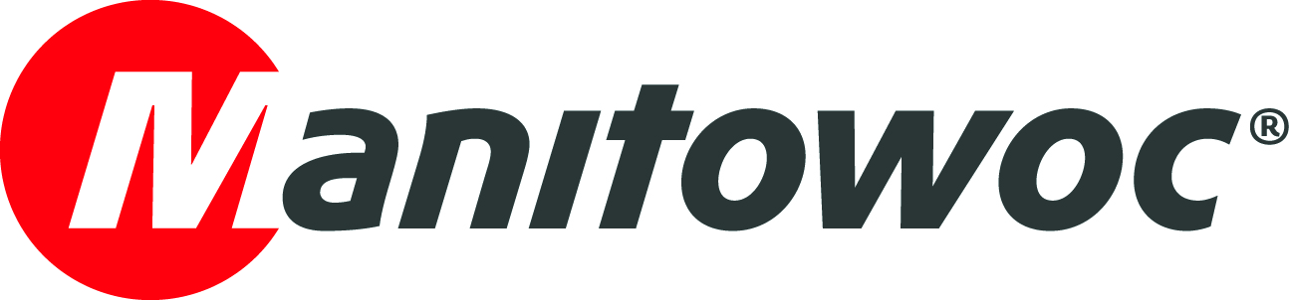
CAPTION RELEASE

January 31, 2019

Potain top-slewing crane constructs 3,000-capacity ‘BioDome’ at famous French zoo



A Potain MD 689 M40 top-slewing crane is helping to construct the new ‘BioDome’ in the famous ZooParc de Beauval in Saint-Aignan-sur-Cher, France.

The MD 689 M40 was installed in March 2018 and is now nearing the end of the project; dismantling is planned for February 2019. When complete, the BioDome will accommodate 3,000 visitors and house Komodo dragons, hippos and manatees.

Contractor CMF Groupe chose the MD 689 M40 due to its ability to handle high capacities and durability when tackling long-lasting jobs.

The MD 689 M40 is the biggest of the Potain MD range. The model installed on-site features a 60-m jib and can lift up to 40 t.

-END-

CONTACT
Cristelle Lacourt
Manitowoc
T +33 472 182 018
cristelle.lacourt@manitowoc.com

ABOUT THE MANITOWOC COMPANY, INC.
Founded in 1902, The Manitowoc Company, Inc. is a leading global manufacturer of cranes and lifting solutions with manufacturing, distribution, and service facilities in 20 countries. In the United States, the Grove, Manitowoc, National Crane, Potain and Shuttlelift brands are sold and serviced by Grove US, LLC, a wholly owned subsidiary of The Manitowoc Company, Inc. In 2017, Manitowoc’s net sales totaled $1.6 billion, with over half generated outside the United States.

THE MANITOWOC COMPANY, INC.
One Park Plaza – 11270 West Park Place – Suite 1000 – Milwaukee, WI 53224, USA
T +1 414 760 4600
www.manitowoc.com

