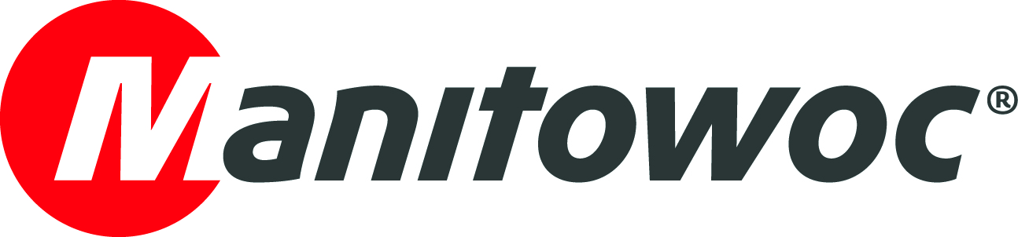
CAPTION RELEASE

April 12, 2019

Lambertsson Kran takes delivery of the first MDT 809 – a tower crane it helped design

Sweden’s Lambertsson Kran has purchased the new Potain MDT 809 on display at Manitowoc’s booth for bauma 2019. The MDT 809 will be available for rental use within the fleets of both Lambertsson and Norwegian crane sales & rental company Kranor AS.

The recently unveiled topless crane reflects a valuable partnership between Potain and Lambertsson. Lambertsson provided design input through Manitowoc’s Voice of the Customer program, one of the key strategies of The Manitowoc Way, which puts Manitowoc’s customers at the center of its business.

Aaron Ravenscroft, executive vice president of cranes at Manitowoc, presented Lambertsson with a celebratory plaque to mark the occasion and thanked Managing Director Jan Heed for his company’s input in the MDT 809’s design.

-END-

CONTACT
Cristelle Lacourt
Manitowoc
T +33 472 182 018
cristelle.lacourt@manitowoc.com

ABOUT THE MANITOWOC COMPANY, INC.
Founded in 1902, The Manitowoc Company, Inc. is a leading global manufacturer of cranes and lifting solutions with manufacturing, distribution, and service facilities in 20 countries. In the United States, the Grove, Manitowoc, National Crane, Potain and Shuttlelift brands are sold and serviced by Grove US, LLC, a wholly owned subsidiary of The Manitowoc Company, Inc. In 2018, Manitowoc’s net sales totaled $1.8 billion, with over half generated outside the United States.

THE MANITOWOC COMPANY, INC.
One Park Plaza – 11270 West Park Place – Suite 1000 – Milwaukee, WI 53224, USA
T +1 920 684 4410
www.manitowoc.com

