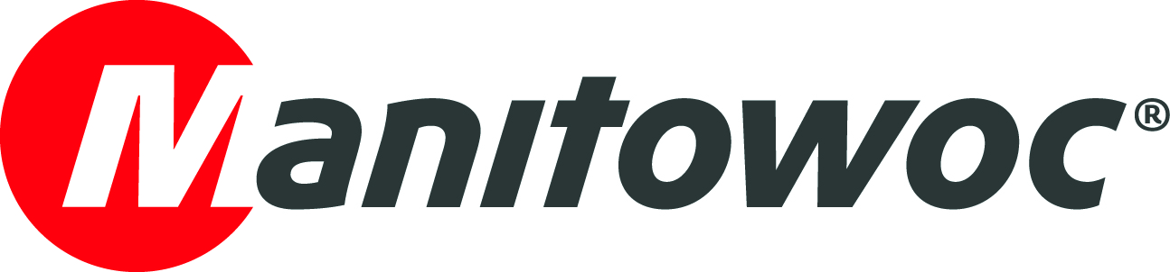
CAPTION RELEASE

April 9, 2019

Kranark wins dealer relationship award at bauma 2019

Manitowoc has recognized its longstanding dealer, Kranark, during bauma 2019. Founded in 2013, Kranark provides both the sale, rental, and superior service of Grove cranes to companies across Russia.

During a special ceremony at the Manitowoc booth, David Semple, Manitowoc’s senior vice president for the Middle East and India, presented a plaque to Kranark’s Alexander Sheremet, who was joined by other Kranark representatives.

“We’d like to take this opportunity to celebrate our strong and growing relationship with Kranark in Russia,” Semple said. “Kranark has really been highlighting the reliability and durability of Grove mobile cranes, and we’re really proud of its achievements.”

-END-

CONTACT
Amy Marten
Manitowoc
T +1 920 683 6345
amy.marten@manitowoc.com

ABOUT THE MANITOWOC COMPANY, INC.
Founded in 1902, The Manitowoc Company, Inc. is a leading global manufacturer of cranes and lifting solutions with manufacturing, distribution, and service facilities in 20 countries. In the United States, the Grove, Manitowoc, National Crane, Potain and Shuttlelift brands are sold and serviced by Grove US, LLC, a wholly owned subsidiary of The Manitowoc Company, Inc. In 2018, Manitowoc’s net sales totaled $1.8 billion, with over half generated outside the United States.

THE MANITOWOC COMPANY, INC.
One Park Plaza – 11270 West Park Place – Suite 1000 – Milwaukee, WI 53224, USA
T +1 920 684 4410
www.manitowoc.com

