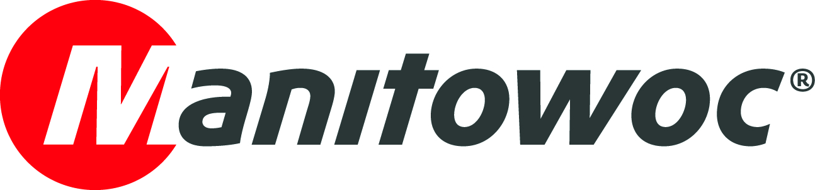
CAPTION RELEASE

November 8, 2019

Manitowoc celebrates 100 Potain crane orders by Valente

Manitowoc has recognized long-term partner Valente for having completed 100 Potain crane orders. The impressive milestone was celebrated during a special ceremony at Batimat 2019.

Established in 1979, Valente is a leading tower crane sales and rental company based in Belley, near Lyon. The company has represented Potain since 1996 and supplies cranes to customers across the Rhône Alpes region.

-END-

CONTACT
Cristelle Lacourt
Manitowoc
T +33 472 182 018
cristelle.lacourt@manitowoc.com

ABOUT THE MANITOWOC COMPANY, INC.
The Manitowoc Company, Inc. (“Manitowoc”) was founded in 1902 and has over a 116-year tradition of providing high-quality, customer-focused products and support services to its markets and its 2018 net sales were approximately $1.8 billion. Manitowoc is one of the world's leading providers of engineered lifting solutions. Manitowoc, through its wholly-owned subsidiaries, designs, manufactures, markets, and supports comprehensive product lines of mobile telescopic cranes, tower cranes, lattice-boom crawler cranes, and boom trucks under the Grove, Manitowoc, National Crane, Potain, Shuttlelift and Manitowoc Crane Care brand names.

THE MANITOWOC COMPANY, INC.
One Park Plaza – 11270 West Park Place – Suite 1000 – Milwaukee, WI 53224, USA
T +1 920 684 4410
www.manitowoc.com

