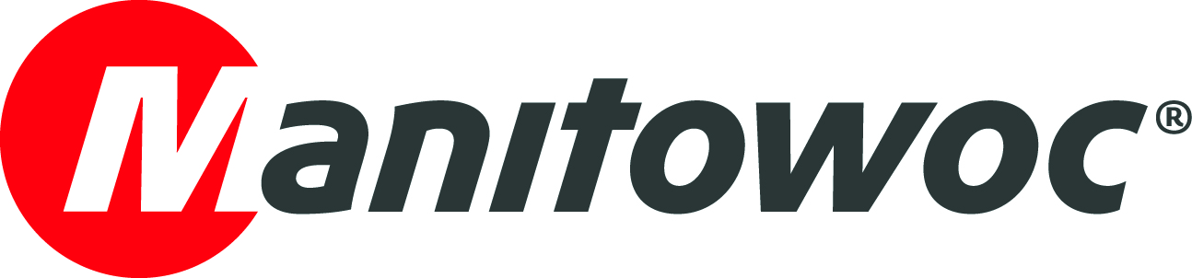
CAPTION RELEASE

July 2, 2019

Potain MCT 385 L14 hailed “Tower Crane of the Year”

The Potain MCT 385 L14 top-slewing crane has won the “Tower Crane of the Year” award at bauma CTT RUSSIA 2019. The award was part of the “Innovations in construction equipment in Russia” contest, which aimed at identifying innovative construction equipment solutions in Russia.

The decision was made by an independent jury, and the award was presented to Jean-Claude Doucene, sales director for CIS countries at Manitowoc, during a special ceremony on June 4, 2019.

The Potain MCT 385 L14 has been popular with customers in Russia since initial deliveries began in 2016. In total, 11 units are working in the country, including seven delivered within the last nine months for the Moscow Renovation Program. More units are scheduled to be delivered soon.

-END-

CONTACT
Cristelle Lacourt
Manitowoc
T +33 472 182 018
cristelle.lacourt@manitowoc.com

ABOUT THE MANITOWOC COMPANY, INC.
The Manitowoc Company, Inc. (“Manitowoc”) was founded in 1902 and has over a 116-year tradition of providing high-quality, customer-focused products and support services to its markets and its 2018 net sales were approximately $1.8 billion. Manitowoc is one of the world's leading providers of engineered lifting solutions. Manitowoc, through its wholly-owned subsidiaries, designs, manufactures, markets, and supports comprehensive product lines of mobile telescopic cranes, tower cranes, lattice-boom crawler cranes, and boom trucks under the Grove, Manitowoc, National Crane, Potain, Shuttlelift and Manitowoc Crane Care brand names.

THE MANITOWOC COMPANY, INC.
One Park Plaza – 11270 West Park Place – Suite 1000 – Milwaukee, WI 53224, USA
T +1 920 684 4410
www.manitowoc.com

